Pi reader

(Document reader device for visually impaired)

**Team 1**

2015311170 Kim Joon Kee

2014314507 Kim Sung Hyun

2018312292 Kim Dong Won

2014313678 Seo Jeong Hwan

2014311409 Shin Won Chul

# Abstruct

The number of visually impaired people is increasing, and the elderly are having hard time reading paper through aged optical sense. Depending on these situations, the market size of visual assistive technology to help them is increasing too. However, existing products in the market have disadvantages in terms of price to performance, communication with users, and portability.

To solve these problems, a cheap document reader device for the visually impaired has been proposed in this paper. Lowing the cost is done by removing functions that are not essential to read documents. This pi reader device extracts text from images taken with a Pi camera using OCR(Optical Character Recognition) and converts extracted text into sound using TTS(Text to Speech). To create a communication environment between device and user in this system, the device generates an appropriate response to the user's request using natural language understanding platform. This system is also linked to the database which supports real-time processing, reflecting data changes for user’s request.

This system is carried out by using Raspberry pi for securing portability which is the main advantage of this device. To ensure that users can use the device conveniently, it is designed to get input voice and button for frequent functions. By using this reader device, the user will be able to read the document anytime, anywhere, repeatably through the device, making the reading process more active and flexible through various functions.

Content

Pi reader 1

(Document reader device for visually impaired) 1

Abstruct 2

Introduction 9

Background 9

Purpose 11

Background Theory 12

Implementation 28

Main framework 28

Google API 31

Dialogflow 39

Firebase 45

Device 57

3D modeling 59

Workflow 80

Result 85

Discussion 85

Limitation 85

Future Supplement 87

Conclusion 87

Appendix 93

**Figure Content**

Figure 1 Demand for assistive-technologies for visually impaired [1] 9

Figure 2 Assistive Technologies for visually impaired market size(2015~2025) [2] 9

Figure 3 Number of people with visual disability in Korea [3] 10

Figure 4 The ratio of elderly over 65 in Korea [3] 10

Figure 5 Process of speech-to-text [4] 12

Figure 8 System Structure of TTS [5] 13

Figure 11 Diagram of conventional Optical character recognition [9] 14

Figure 12 the network architecture of EAST [10] 15

Figure 13 explain how the geometry module of EAST work [10] 15

Figure 14 learning and recognizing process of the entire model [11] 16

Figure 15 Flow for Intent Matching and Responding to the End-User [12] 17

Figure 16 Building Intends with Entities in Dialogflow 18

Figure 17 Testing if Dialogflow Produces Same Outcome from Different Input 19

Figure 18 Nosql database models [13] 20

Figure 19 Cloud Firestore 21

Figure 20 Cloud Firestore Data Model [15] 22

Figure 21 Several fields in “todolist” document 22

Figure 22 Several documents in “diary” collections 23

Figure 23 Sample of Pi Camera [17] 24

Figure 24 Membrane 3 Button 24

Figure 25 Raspberry Pi 4B pin map 25

Figure 26 general circuit 25

Figure 27 Circuit switch off & switch on 26

Figure 28 Headset image 26

Figure 29 Assembly of power supply board with Raspberry pi [21] 27

Figure 30 Example use of Battery Module [22] 28

Figure 31 usage of snowboy 29

Figure 32 test of snowboy 29

Figure 33 snowboy conflict with google cloud sdk 29

Figure 34 training procedure for own hotword 30

Figure 35 usage of picovoice 30

Figure 36 permit to json file in google cloud console 31

Figure 37 architecture of Tesseract [26] 32

Figure 38 the architecture of EasyOCR [25] 32

Figure 39 a) original image with Raspberrypi4 box b) tesseract result c) easyOCR result, All executions of code were ran in google colab(Intel(R) Xeon(R) CPU @ 2.30GHz, Tesla P100) (s mean seconds) 33

Figure 40 a) preprocessed from original image b) Tesseract result c) easyOCR result, same execution environment with Figure 39, (s mean seconds) 33

Figure 6 Testing Google STT 35

Figure 7 Testing Pocketsphinx 36

Figure 9 Test Code of Google TTS [7] 37

Figure 10 Test Code of Espeak TTS [8] 38

Figure 41 usage of google cloud vision api and dialogflow api 38

Figure 42 test images captured with picamera and ocr output 39

Figure 43 List of entities built for the project 40

Figure 44 Entity building page in Dialogflow 40

Figure 45 Entities and its words used in the project 41

Figure 46 List of intents built for the project 41

Figure 47 Intent making process – training phrases 42

Figure 48 mark_make function when using firebase 43

Figure 49 mark_make function when using fulfillment text 43

Figure 50 Intends used in Pi reader 45

Figure 51 Cloud Firestore DB schema 46

Figure 52 “Text” field in summer category 47

Figure 53 Data fields in status document 47

Figure 54 Extracting bookmark call information 48

Figure 55 mark call command db transaction code 49

Figure 56 Fields in “status” document(before) 50

Figure 57 Fields in status document(after) 50

Figure 58 Text Field in “summer” category 51

Figure 59 Extracting bookmark save information 51

Figure 60 mark save command db transaction code 52

Figure 61 Fields in “status” document(before) 53

Figure 62 Fields in status document(after) 53

Figure 63 Field in “summer” (before) 54

Figure 64 Field in “summer” (after) 54

Figure 65 Extracting make category information 54

Figure 66 make category command db transaction code 55

Figure 67 Documents in bookmark(before) 56

Figure 68 Documents in bookmark(after) 56

Figure 69 Update mark_index field 56

Figure 70 Update mark_index_num field 57

Figure 71 The sound configuration file of PiReader 58

Figure 72 raspberrypi board that is connected with battery module 58

Figure 73 existing design of the case 60

Figure 74 design for the case 60

Figure 75 free shared tripod design 61

Figure 76 free shared smartphone holder design 62

Figure 77 horizontal minimum considering horizontal angle 63

Figure 78 minimum height considering verical angle 63

Figure 79 calculating angles between the arms 64

Figure 80 modifying the smartphone holder 65

Figure 81 case: bottom & top 66

Figure 82 connector between the case and the holder 66

Figure 83 arm1 & arm2 67

Figure 84 document locator 67

Figure 85 Simulation: total assemble 68

Figure 86 modified case: front 69

Figure 87 modified case: bottom 69

Figure 88 modified case: top 70

Figure 89 modified holder: document locator 70

Figure 90 1st print with Makerbot 71

Figure 91 printing the first part with Makerbot 72

Figure 92 printed design with Makerbot 73

Figure 93 2nd printing with Cubicreator 310F 73

Figure 94 printed 2nd part with Cubicreator 310F 74

Figure 95 3rd printing with Cubicreator 310F 75

Figure 96 3rd part printed by Cubicreator 310F 75

Figure 97 4th printing with Cubicreator 210F 76

Figure 98 4th printed part by Cubicreator 210F 77

Figure 99 the device 77

Figure 100 additional PCB supports 78

Figure 101 fix the camera module and the top part of the case 78

Figure 102 fix the top part to the device 79

Figure 103 Assemble the case and the holder 79

Figure 104 Total hardware with user 80

Figure 105 Sequence diagram for voice control (find control) 81

Figure 106 Sequence diagram for button input(volume increase) 82

Figure 107 Sequence diagram for voice control(bookmark call) 83

Figure 108 Sequence diagram for voice control(weather control) 84

Figure 109 overall architecture 85

Figure 110 Rapsberry Pi zero W [32] 87

**Table Content**

Table 1 Speech recognition test between Google STT and Pocketsphinx 36

Table 3 comparison between two fulfillment methods 43

Table 4 Test of two methods 44

Table 5 Data fields in status document 48

# Introduction

## Background

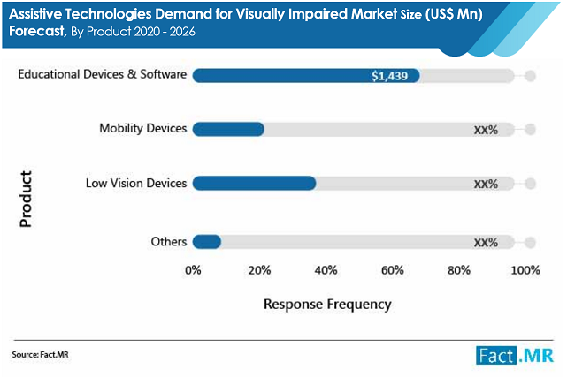

Figure Demand for assistive-technologies for visually impaired (FACT.MR, 2021)

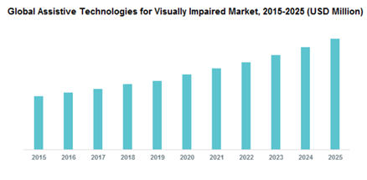

Figure Assistive Technologies for visually impaired market size(2015~2025) (Adroit Market Research, 2019)

As shown in Figure 1, Driven by these technological advancements, the assistive technologies demand for visually impaired market is projected to grow impressively, registering a CAGR of 8.6% during the forecast period (2020-2026). Product-wise, the educational devices & software segment shall constitute the maximum share of the assistive technologies demand for visually impaired market. Projections indicate a market share of around 58%. This is due to increased spending on education by public and private entities. Assistive Technology(AT)’s market size has been increasing for years and is expected to grow steadily in the future. Among several Assistive Technologies, we focused on assistive technology for the visually impaired market. The growth of assistive technology for the visually impaired market is increasing over the years just like the growth of assistive technologies as in figure 2(4.7 billion dollars in 2019, 5.6 billion dollars in 2025).

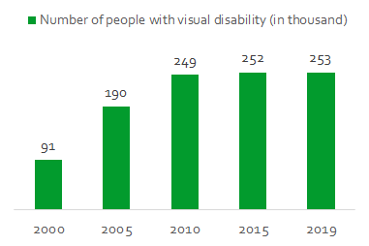

Figure Number of people with visual disability in Korea (YUN-HWANCHAE, 2019)

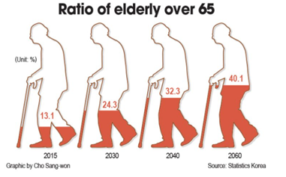

Figure The ratio of elderly over 65 in Korea (YUN-HWANCHAE, 2019)

Among the many reasons for increasing assistive technology for visually impaired market size, the main reasons are the increase in the number of visual disability populations and increase in the proportion of the aging population as shown in Figure 3 and Figure 4. So, the project chose target who are visually impaired and need help educational device with functional software. In shoes of blurred vision people, what could be the first problem they can get hit? The project concluded that the first of every problem starts with reading so device which does not need eyesight and output without vision are needed for them. Also, additional functions are needed such as remembering main context.

## Purpose

Even though market for Assistive Technology has been grown fast, devices suitable for visually impaired are needed. There are three problems when analyzing the products from market. First, products which is convenient and useful are too expensive. Second, cheap products have poor quality and reading process is inconvenient so that it is better not to use it. Third, product is not user friendly since commands or input actions are difficult.

In the cost aspect, cost and performance has trade-off relation. Reading device should be reasonable enough in cost and performance. For the user interface, user friendly technology such as voice recognition should be used. Through these efforts, providing a convenient reading service communicating between device and user becomes possible.

To realize these goals, the solution can be eliminating unnecessary functions in existing products and understanding what function is frequently used. Plus analyzing appropriate input approach is also important. Therefore, lower the price can be done by only implementing functions that are related to the main function and finding proper device just enough to fulfill our function performance. By using existing COTS(Commercial off-the-shelf) and API(Application Programming Interface) for consistent performance, the performance can be improved. Dialogflow for efficient communication and FireBase Database for real-time communication can make using the device conveniently for user.

# Background Theory

### Speech-to-Text(STT)

Speech-to-Text (STT) function recognizes spoken words from the user and converts them into text data. STT function is used to transfer user commands into digital data.



Figure Process of speech-to-text (PrasadP., 2015)

STT function proceeds in the following steps. First voice signal is input by the user. Then extraction process, which retains useful information of the signal, deducts unwanted or redundant information. For example, background noise or stuttering should not be recognized as an input signal. Then, the decoding process occurs. In the decoding process, it utilizes an acoustic model and language model to make the desired output. The acoustic model is used in speech recognition to indicate the relationship between speech signals and phonemes or other linguistic units that make up speech. Each word is constructed by using recorded speech signals, transcription, and software to generate statistical representations of sounds. The language model assigns probabilities to word sequences. (PrasadP., 2015) To put it another way, the language model finds the most natural word sequence.

### Text-to-Speech(TTS)

TTS system produces audio data from the given text. Intelligence and naturalness are the two important characteristics of TTS system. However, intelligence and naturalness inevitably tend to contradict each other. This is because when clarity improves, naturality decreases, and when naturality improves, clarity decreases. Therefore, the main purpose of the model is to create a natural voice by combining two conflicting properties as well as possible.

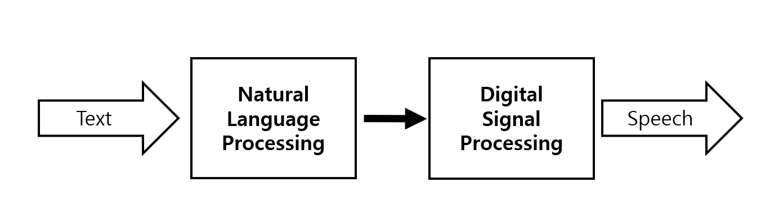

Figure System Structure of TTS (JunghoC., 2003)

TTS consists of the following steps. First, the user inputs the text. Subsequently, the input text goes through Natural Language Processing. Natural language module is the essence of TTS service and it consists of analyzer, phonetization and prosody generation modules.

Text analyzer consists of four parts. First part is pre-processing block that converts numbers, acronyms, abbreviations into full text. For example, the phrase 2:30 is converted to half past two. Second part is morphological analysis block. Here, the process of applying all possible pronunciation categories through each words’ spelling is performed. Last part of block is called contextual analysis module that streamlines the list of possible parts of speech of words in sentences, by considering the parts of speech of neighboring words. (OnaolapoJ., 2014)

In the phonetization part, letter to speech module is used. Pronunciation of a word differs depending on what part or meaning it has. For example, the word address put emphasis on the ‘add’ part when it is noun and ‘ress’ part when it is verb. The letter to speech module analyzes this.

In the prosody generation process, pronunciation differences made by contextual emphasis and relationship between words are analyzed. Generation of a natural-sounding prosody is one of the biggest challenges faced in the design of Text-To-Speech systems. (OnaolapoJ., 2014)

The Digital Signal Processing (DSP) part takes care of the 'pronunciation' of sentences (based on the outputs of NLP process. DSP process is performed by either rule-based synthesizer or concatenative synthesis.

### Ocr

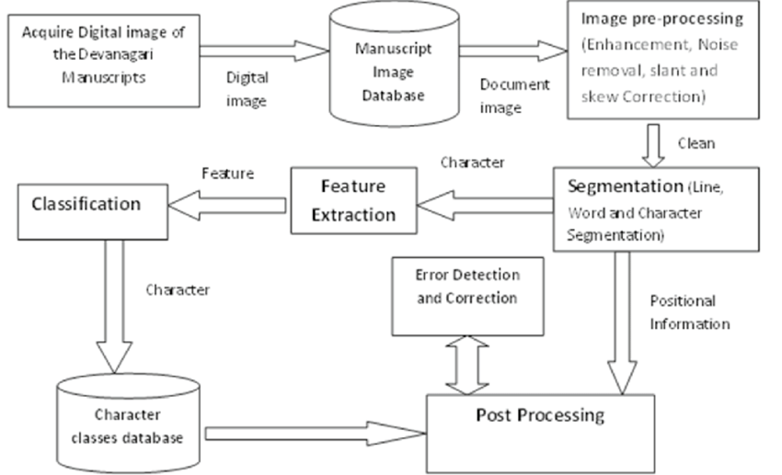

Figure Diagram of conventional Optical character recognition (KurmarMunish)

OCR means optical character recognition. Get text data from a digital image. It follows the diagram in Figure 7. It is similar to object detection, but text objects have some properties different from other objects. The text has clear edges. By detecting those edges, text detection was possible in the past. This technique makes it hard to recognize variable conditions. The background will affect detect edges, and noise from the image can affect it too. Conventional text detection was limited to detect from clear document image, textbook or electric document like pdf. After find edges, the next job is extracting words or characters by segmentation. This job is also difficult. Words can be stuck together. Or they can be rotated or skewed. This makes segmentation jobs harder. Next is feature extraction. Extracted regions of interest will be classified into characters or word by clustering in traditional methods. Fonts are the main dataset of clustering. tesseract completes those functions delicately.

This traditional OCR techniques look tough to implement. However, after deep learning came to the fore, all techniques became meaningless. Text detection show powerful performance and fast execution time in a GPU environment. Here is one of the best text detection models, EAST (Xinyu ZhouCong, 2017). Recent text detection models are coming from EAST, therefore we will explain this architecture for example.

EAST is inspired by FPN. FPN takes pieces of information from both low-level layers and high-level layers. So output layer got multiple receptive field information. For this reason, EAST use this network for feature extraction. Texts have many different sizes. They can take half of the image or a very small portion of the image. Multiple receptive fields make EAST can get many text information. EAST’s output layer comes with the following things.

1. Pixels of the output layer is text or background (1 channel )
2. From the pixel, distance of the line of the text box.
3. Rotation of angle with the box.

By combining those target labels, EAST can learn from the dataset easily and show great performance than the conventional method of text detection.

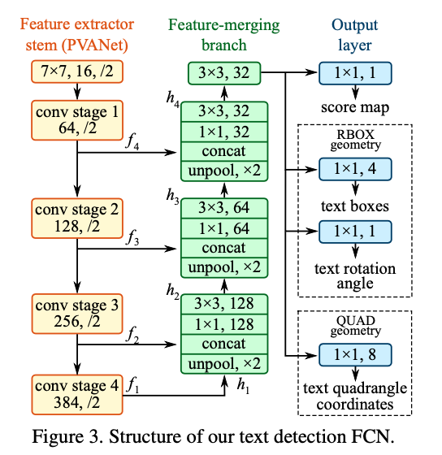

Figure the network architecture of EAST (Xinyu ZhouCong, 2017)

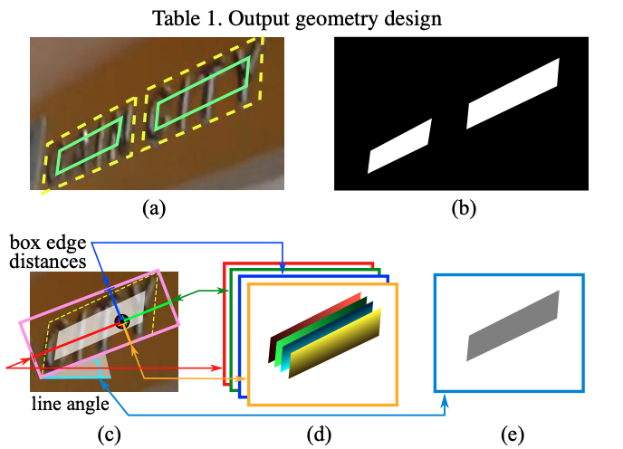

Figure explain how the geometry module of EAST work (Xinyu ZhouCong, 2017)

Next is text recognition. Similar to EAST, current text recognition models are based on CRNN from the paper called An End-to-End Trainable Neural Network for Image-based Sequence Recognition and Its Application to Scene Text Recognition. (Baoguang ShiXiang, 2015)

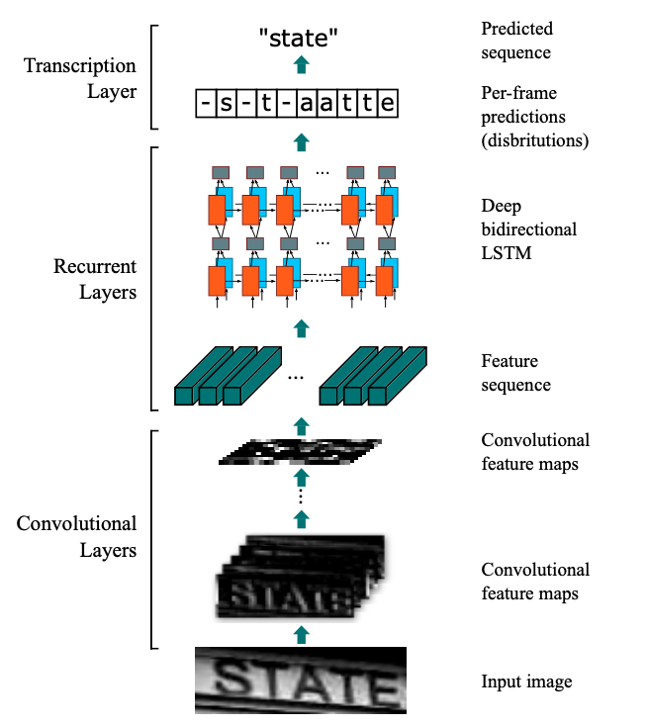

Figure learning and recognizing process of the entire model (Baoguang ShiXiang, 2015)

This network looks simple.

1. Get feature sequence from the image by a convolutional neural network(CNN).

2. From extracted feature sequence, Get per frame character prediction by a recurrent neural network(RNN).

3. From per frame character prediction, Get predicted sequence by CTC decoder.

Feature sequence that comes from CNN which extract visual cue by convolutional filter has information of image that includes certain part of the image. With this information, RNN module like LSTM is used for interpreting character from feature sequences. The reason why CRNN Using the RNN module with CNN is that there are tremendous words in the world. We can’t train CNN to recognize all of the words. Therefore, network should predict character by character with the visual cue. Those visual cues are used properly with RNN that is interprets sequence data because the text is the sequence. RNN will predict whether the input sequence is space or character. After that, CTC decoder which is combine predicted value and make all possible sequence. Compare with ground truth target text, they can get the score of loss to train. When testing time, the CTC decoder will not be used.

### Dialogflow

For the voice command function, a customized chatbot is to be used. Entity and intend are used to build a chatbot function. The first User’s intent should be extracted from the input dialog. For example, when the user says can you set the volume to 5 to the chatbot, the chatbot should extract the intent, user’s purpose, form the keywords. In this case, volume, and integer 5 should be selected as a keyword. This keyword is an entity.

Second entities should be categorized. One intent can be spoken in dozens of ways, for example, the bookmark function we are trying to implement can be spoken as: “Clip the sentence”, “Mark this line” and, “move this quote to the bookmark”. In these sentences, although the words clip, mark, and bookmark are all different, the same intent should be extracted. So, those words should be categorized together.

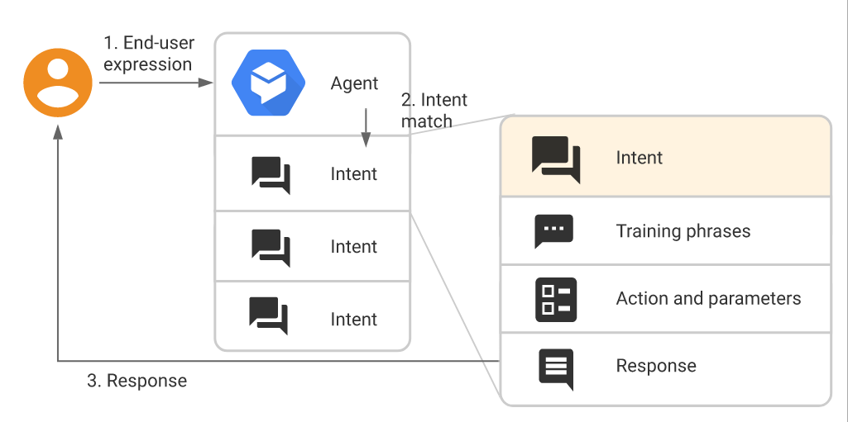

Figure Flow for Intent Matching and Responding to the End-User (Google Cloud, 2021)

Dialogflow will be used as a platform to build a chatbot. As Dialogflow uses google SST and supports natural language processing, it can provide excellent interaction. Moreover, it is also easy to build intent and entities, and deploying it to the database and other applications is also easy.

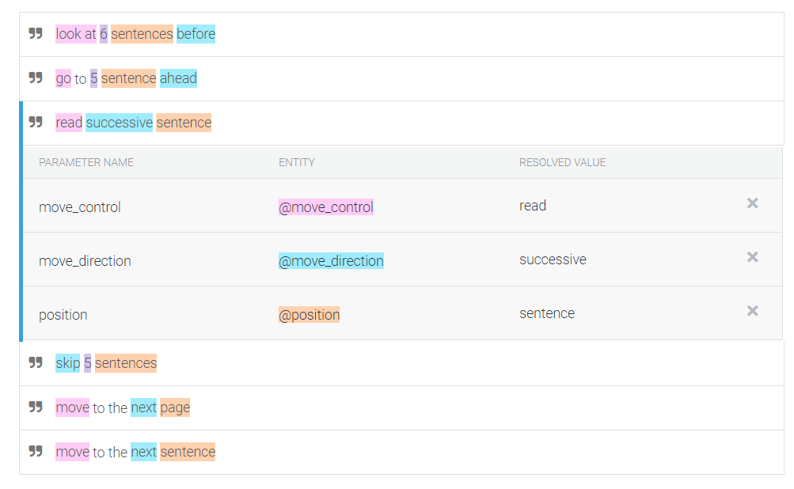

Figure Building Intends with Entities in Dialogflow

For the project, intends and entities were built. The above image is the intent which moves a page or sentence in the desired direction by a specified number.

In the sentence above, pink highlighted words such as move, go, read, look at are the intents that provoke the intents. Blue highlighted words represent the direction of the movement. If this entity is 'ahead', the user will read the successive lines. Orange highlighted words to determine whether to move in sentences or pages.

Also, responses should be made to occur differently depending on the type of entity. Depending on what value the entity represents, the same or different responses should be made.

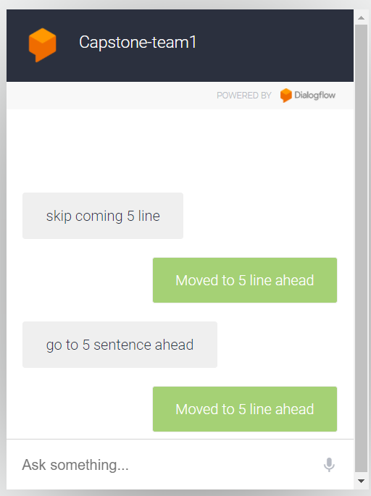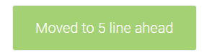

Figure Testing if Dialogflow Produces Same Outcome from Different Input

The above figure shows an experiment with customized Dialogflow. Even if different inputs were received, if the type of the entity is the same, the same output must be generated. For example, since “skip” and “ahead” are pointing in the same direction, the direction must be the same. In the test, Dialogflow produced the same outcome, “Moved to 5 lines ahead” from two different dialogs, “Skip coming 5 lines” and “Go to 5 sentences ahead.”

### Firebase

1. NoSQL

NoSQL database provides a mechanism for storage and retrieval of data that is modeled in means other than the tabular relations used in relational databases. It excels in their ease-of-use, scalability, resilience, and availability characteristics. Instead of joining tables of normalized data, NoSQL stores unstructed or semi-structed data, often in key-value pairs or JSON documents making some operations faster in NoSQL. The particular suitability of a given NoSQL database depends on the problem it must solve. Sometimes the data structures used by NoSQL databases are also viewed as "more flexible" than relational database tables. NoSQL databases include several different models for accessing and managing data, each suited to a specific use case. (Relational vs. NoSQL data, 2021)

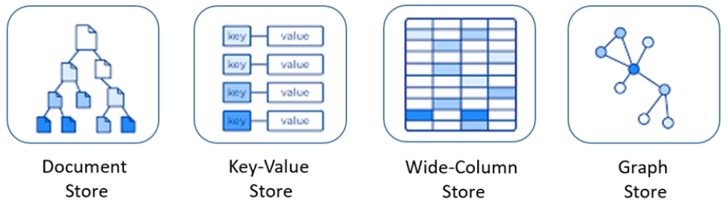

Figure Nosql database models (Relational vs. NoSQL data, 2021)

NoSQL databases include several different models for accessing and managing data, each suited to specific use cases.

* 1. Document store

Data are stored hierarchically in JSON-based documents inside the database.

* 1. Key-Value store

The simplest of the NoSQL databases, data is represented as a collection of key-value pairs.

* 1. Wide-Column store

Related data is stored as a set of nested- key/value airs within a single

column.

* 1. Graph Store

Data is stored in a graph structure as node, edge, and data properties.

1. Cloud Firestore

Firebase is Google’s mobile application development platform that helps developer build, improve, and grow application. Among several products in firebase, Cloud Firestore provides cloud hosted, NoSQL database service for storing and sync data. (Firebase, 날짜 정보 없음)



Figure Cloud Firestore

Cloud Firestore is a flexible, scalable database for mobile, web, and server development from Firebase and Google Cloud. Like Firebase Realtime Database, it keeps data in sync across client apps through realtime listeners and offers offline support for mobile and web, so developer can build responsive apps that work regardless of network latency or Internet connectivity. (Firebase, 날짜 정보 없음) Cloud Firestore also offers seamless integration with other Firebase and Google Cloud products, including Cloud Functions. There are several Cloud Firestore’s key capabilities as follows.

1. Cloud Firestore Key Capabilities
   1. Flexibility

Data model supports flexible, hierarchical data structures.

* 1. Expressive querying

Developer can use queries to retrieve individual, specific documents or to retrieve all the documents in a collection that match query parameters.

* 1. Realtime updates

It uses data synchronization to update data on any connected device.

* 1. Offline support

It caches data that app is actively using, so the app can write, read, listen to, and query data even if the device is offline. When the device comes back online, Cloud Firestore synchronizes any local changes back to Cloud Firestore.

* 1. Designed to scale

It brings the best of Google Cloud's powerful infrastructure: automatic multi-region data replication, strong consistency guarantees, atomic batch operations, and real transaction support. (Firebase, 날짜 정보 없음)

1. Cloud Firestore Data Model

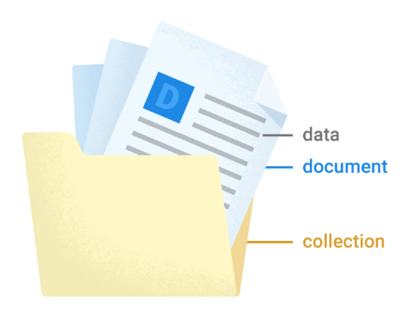

Figure Cloud Firestore Data Model (Firebase, 날짜 정보 없음)

Cloud Firestore is a NoSQL, document-oriented database, which is that data and metadata are stored hierarchically in JSON-based documents inside the database. Unlike a SQL database, there are no tables or rows. Instead, it can store data in documents, which are organized into collections. As Cloud Firestore is schema-less, developer can have complete freedom over what fields developer put in each document and what data types designer store in those fields. Documents within the same collection can all contain different fields or store different types of data in those fields. (Firebase, 날짜 정보 없음)

1. Document

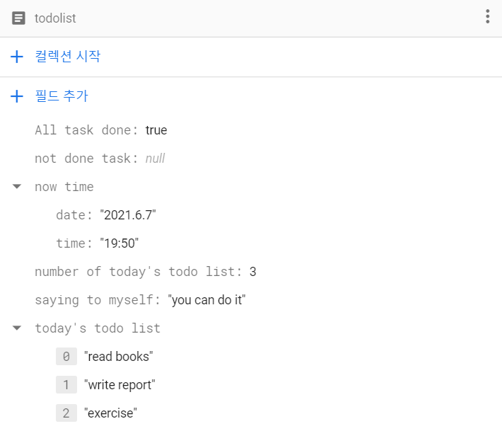

Figure Several fields in “todolist” document

In Cloud Firestore, the unit of storage is the document. A document is a lightweight record that contains fields, which map to values. Each document contains a set of key-value pairs. For example, like in Figure 17, “todolist” document contains several fields. As shown in “todolist” document, Cloud Firestore supports a variety of data types for values such as number, string, array, maps(nested object), boolean, null, geopoint, binary blob, and timestamp. (Firebase, 날짜 정보 없음)

1. Collection

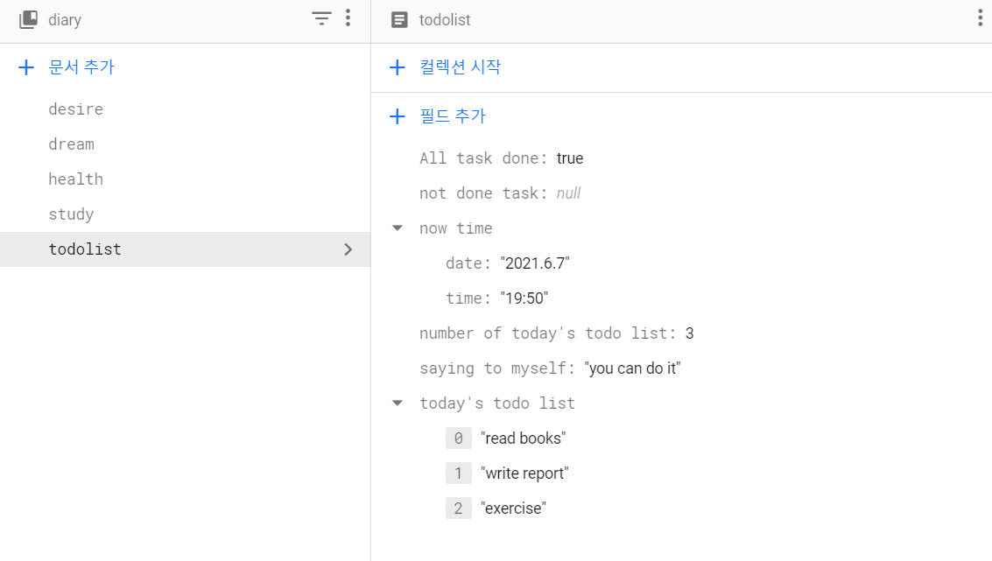

Figure Several documents in “diary” collections

Documents live in collections, which are simply containers for documents. As shown in Figure 18, “diary” collection contains several documents such as “desire”, “dream” and so on. Like this, collection contains documents and nothing else. It cannot directly contain raw fields with values, and it can't contain other collections.

Using this data element such as “document”, “collection”, “filed(data)” and applying subcollection concepts, developer can create hierarchical data structures which is easy to handle data fields.

### Device

For the side device, a camera, mic, speaker, battery module and packages for the modules are needed for the project.

1. Pi Camera

The Raspberry Pi Camera Module is official product form Raspberry Pi Foundation. The original version which was released in 2013 had 5-megapixel but version 2 was upgraded to 8-megapixel. The size of the Camera board is around 25mm x 20mm x 9mm. It also weighs just over 3g, making it unflawed for mobile or other applications where size and weight are important like our project. It connects to Raspberry Pi by way of a short ribbon cable. And it is connected to the BCM2835 processor on the Pi via the CSI bus, a higher bandwidth link which carries pixel data from the camera back to the processor.

In terms of still images, the camera is capable of 2592 x 1944 pixel static images, and also supports 1080p30, 720p60 video enough to clearly view texts we need for our project. The camera is supported in the latest version of Raspbian, Raspberry Pi's operating system we are going to use.

In software aspect, there are lots of examples. For beginners time-lapse, slow-motion, and other video cleverness can be used easily. We can also use the libraries we bundle with the camera to create effects. And for the Software features, many balancing mode is mounted to control camera such as automatic exposure control, automatic white balance, automatic band filter, automatic 60 Hz luminance detection, automatic black level calibration

Figure 19 shows the sample of Pi camera. Turned the camera module clockwise to the end and turned 135 degrees counterclockwise to take a picture about focus. 5 Lego blocks were used from camera distance 10cm each. The change of the focusing could be checked by the picture. (GeekRaspberry, 2018)

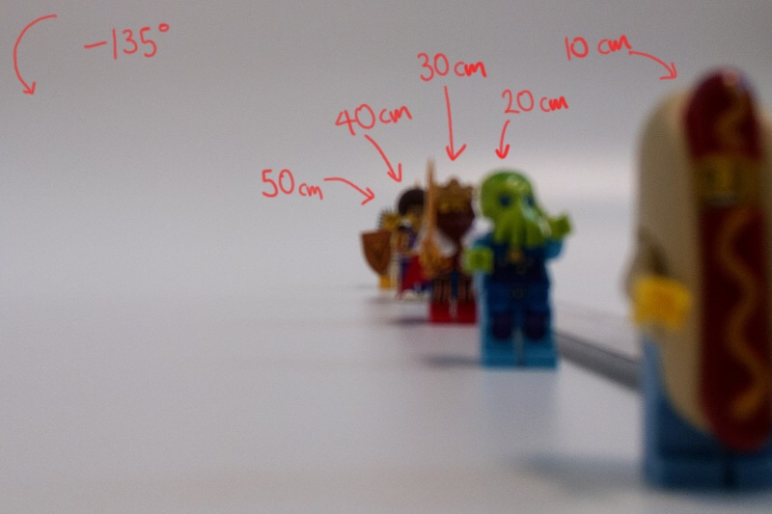

Figure Sample of Pi Camera (GeekRaspberry, 2018)

1. Button

Button is easily used for the user cause it just only need click to input.

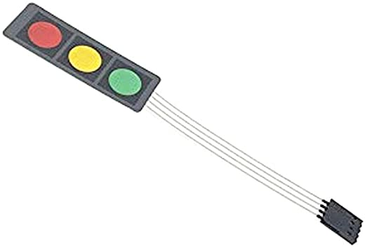

Figure Membrane 3 Button

The trick part is the pin map which tells us where to connect the cable. The pin map for the raspberry Pi 4B model is shown below. GPIO(General Purpose IO) number based on wiringPi are 0, 2, 3, Ground. Making switch button needs Ground to denote True or False.

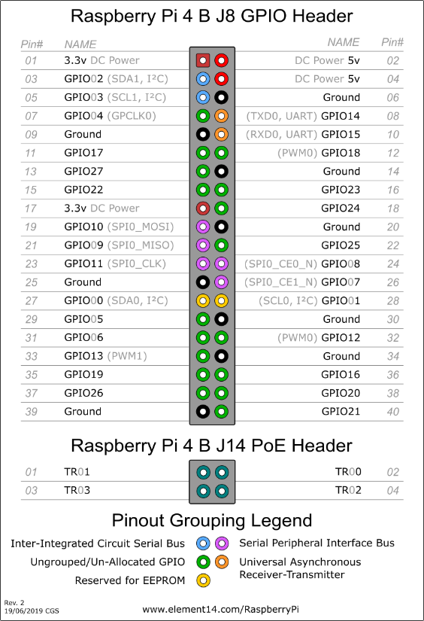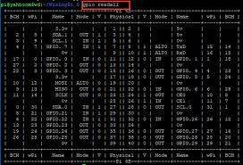

Figure Raspberry Pi 4B pin map

When making code for switch button, setting pull up or pull down resistance is needed. When it is not set up, the input value will not be different before and after pushing buttons. This is because of “floating”. Floating is the state when signal is between 0(LOW) and 1(High) in neutral location.

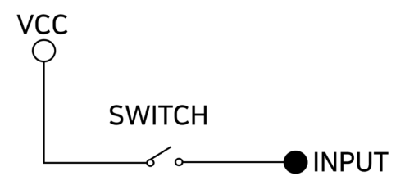

Figure general circuit

When switch is open, it cannot be known if the signal is made by input or output pin. It could be both True or False. With Pull-up circuit, this problem can be solved. Pull-up means attaching resistance towards power to solve floating.

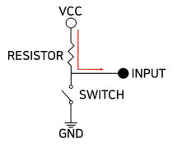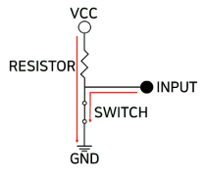

Figure Circuit switch off & switch on

When switch is off, current flows from power to IO(input and output) pin. So the value of IO pin is High(1). When switch is on, all current flows to ground. Therefore, the value of IO pin is LOW(0).

Fortunately, Raspberry Pi can use Pull up circuit in software without connecting in hardware.

In summary, button code should be include setup, input/output mode setting, interrupt function to connect to the interrupt, and attaching function. All buttons used pull up circuit in software. (devicemart, 2019)

1. Headset

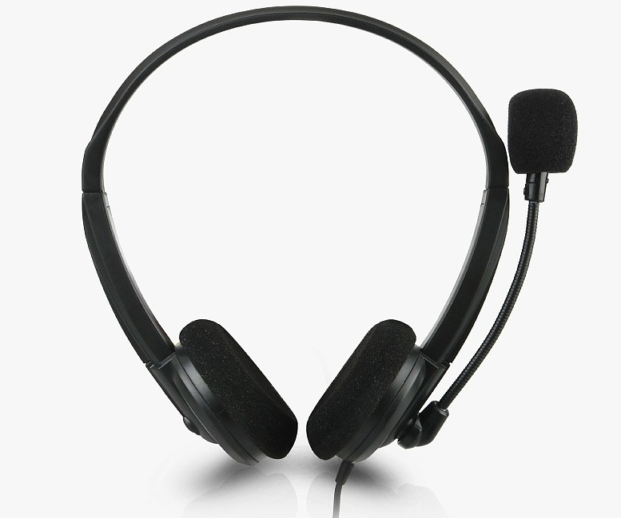

Figure Headset image

Headset combines microphone and speaker, so it is more convenient to set and use. For the portability, the weight of headset should be considered. Course the quality of the sound and weight are in trade-off relation limit to the performance should be set. Connection for raspberry Pi 4B should be also considered. Raspberry Pi 4B has only 3-pole so it needs 4-pole to 3-pole convert gender enclosed.

For the software part, there are many options. Among them, Pygame.mixer module is usually used to load and play .mp3 files in Raspberry Pi. Process is initialization with frequency, size, channel, buffer and play. Various kinds of functions are capable such as setting volume, music stop, music resume, fadeout etc. Code should include init, playPause, play, pause, resume, next_5s, previous_5s, volumeUp, volumnDown, setVolumn. playPause function plays the file when paused and pause the file when it is playing. Volume function has range 0 ~ 1 and control ratio is 10%. (pygame, 날짜 정보 없음)

1. Battery module

For the portable device, rechargeable battery is needed. Rechargeable battery consisted of

power expansion board, Li-ion rechargeable battery, charging module. Power expansion board makes the user can be used as portable. Also, micro 5 pin USB port is fitted so power supply through USB is available. Moreover, USB power supply mode and battery power supply mode can be transferred easily. When power supply method needs change or battery exchange is needed, there is no need to turn off raspberry pi with expansion board. With supports, expansion board can be fastened to raspberry pi. Input battery compatible to board are 18650 Li-ion batteries for stable power supply. With Li-ion battery, 5V 2A can be supplied. (devicemart, 날짜 정보 없음)

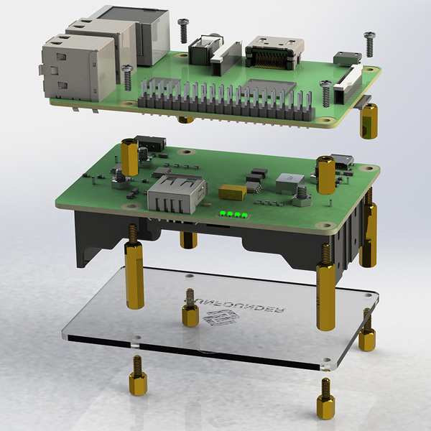

Figure Assembly of power supply board with Raspberry pi (devicemart, 날짜 정보 없음)

Battery Module can charge Raspberry Pi 4B wireless. And output of this module should be 5V and above 3A so that this is capable in Raspberry Pi 4. For simplicity, module should not need battery charger and other wire work. For example, 18650 5V 4A UPS charging module SZH-RPI01 gets input with USB micro B type (micro 5 pin) and print output to USB C type and for the Raspberry Pi pogo-pin is available. Separately power switch is applied so that module can easily on/off with button. And separately LED is built-in so that remaining battery can be visualized easily. From the inside circuit, overvoltage and overcurrent will be protected.

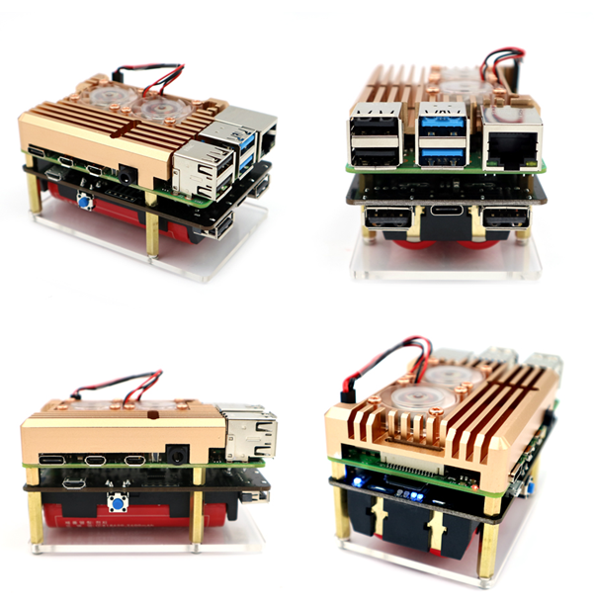

Figure Example use of Battery Module (MCU보드, 날짜 정보 없음)

# Implementation

## Main framework

Hotword detection is needed for voice command that is open audio stream and continuously receive chunk of data and get what they want from that. This technique needs to be fast and efficient. It is hard to train by us. Therefore at First, PiReader adopt snowboy[9], which is most popular open source hotword detection tool as shown in Figure 27. Although it is ease of use and being able to make own hotword, kitt-ai which is creater of snowboy, shutdown their service including make hotword and support maintenance. Therefore, snowboy should be trained for this project.

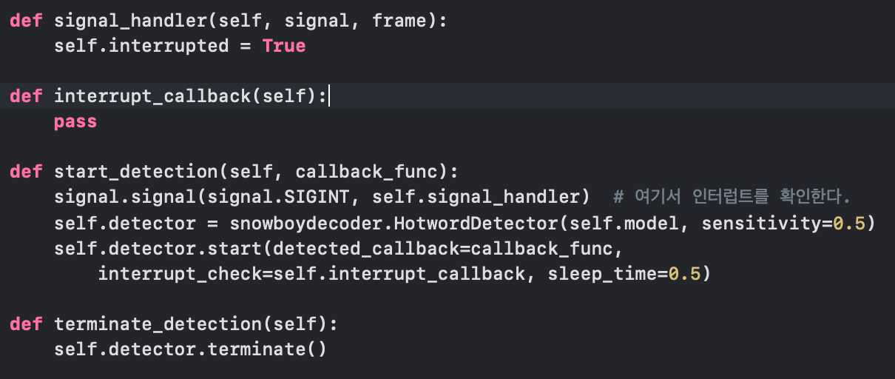

Figure usage of snowboy

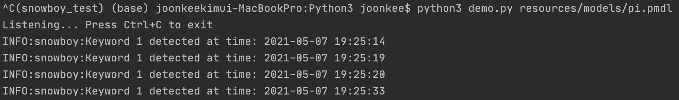

Figure test of snowboy

It works very well in both development and raspberrypi environment. However, there are major issue of using snowboy. Snowboy’s binary compiled library make conflict with google cloud sdk. (Figure 29)

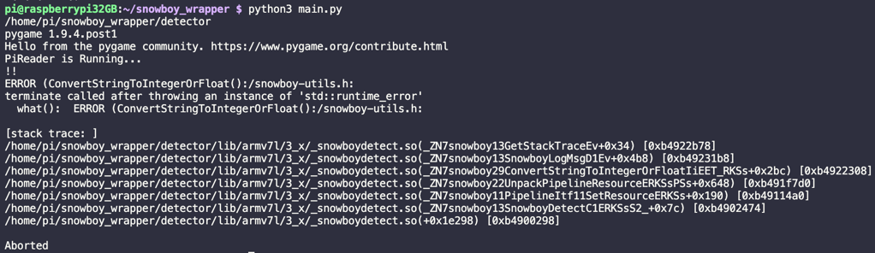

Figure snowboy conflict with google cloud sdk

There were many trials of using google cloud and snowboy both, because of credit we put in so far, every trials were failed. This is because of snowboy’s unsustained update following dependency. Other projects that using snowboy changed hotword engine to other. PiReader decide to use picovoice (picovoice, 날짜 정보 없음) that is also popular and much more easy to use. Snowboy are implemented with c++, so it needed python wrapper to use, but picovoice simply open the streaming audio input channel and find the hotword.

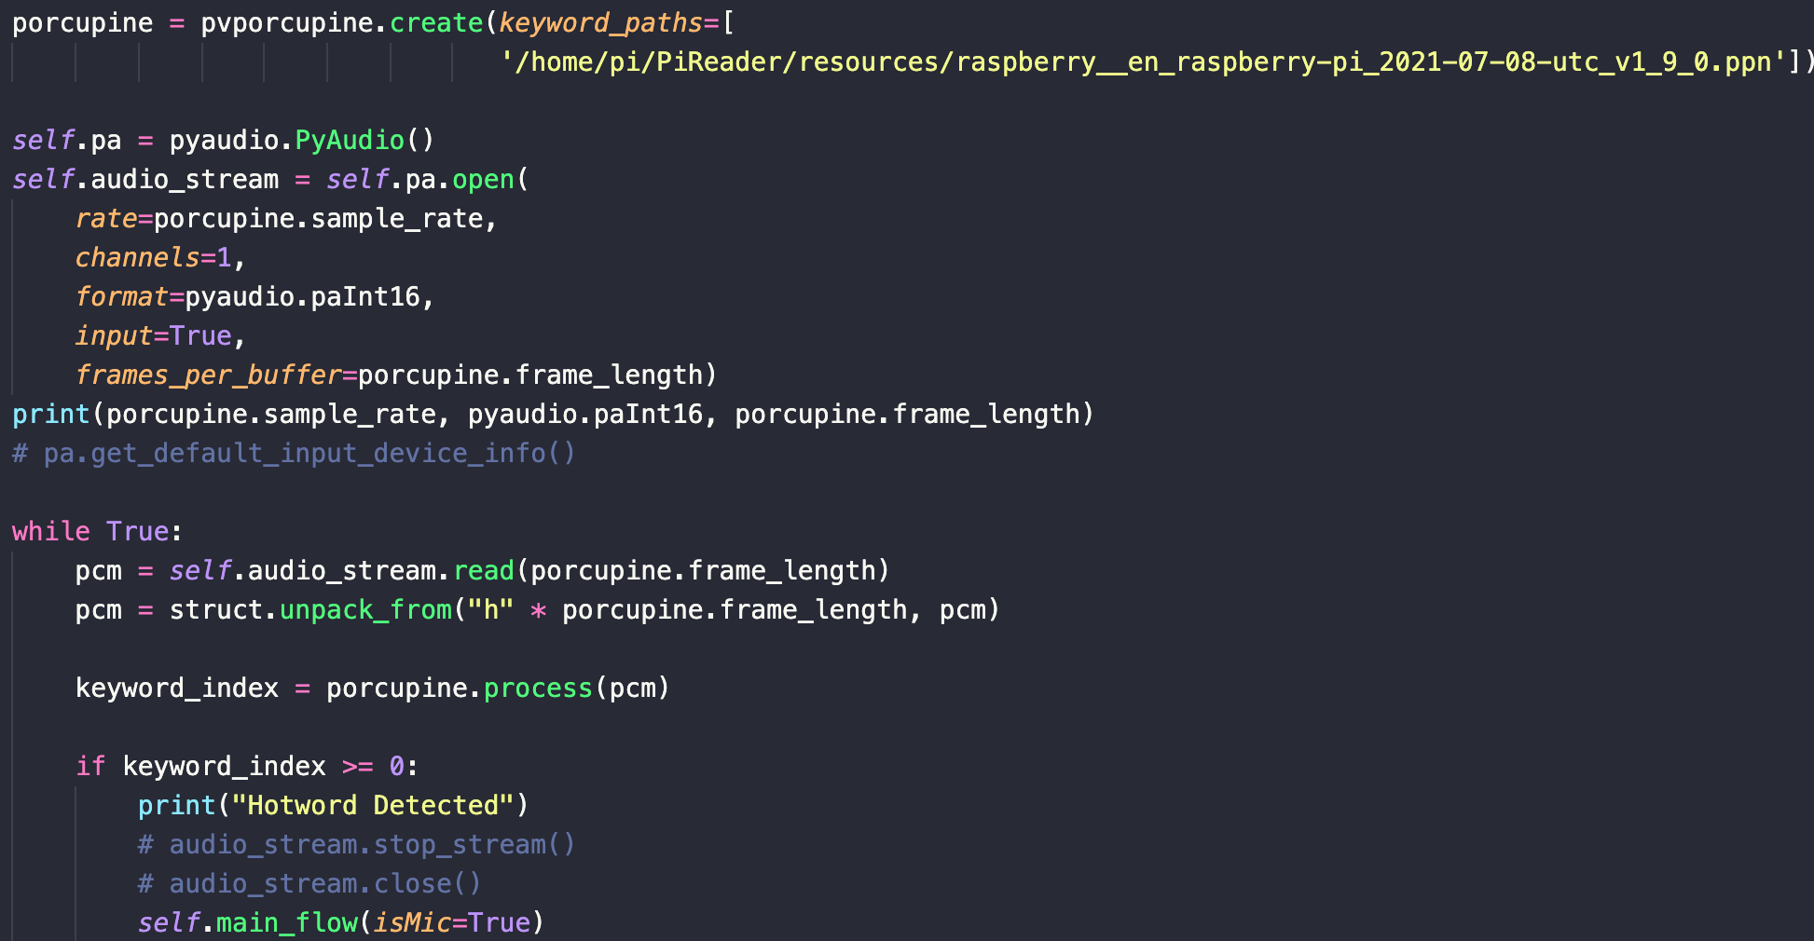

Figure training procedure for own hotword



Figure usage of picovoice

Furthermore, they still manage their own website which provide training functions. For PiReader, word “raspberry” is trained in 4 hours and this model is used to detect hotword. Picovoice is used as Figure 31, they read chuck from stream and unpack it and find similarity with hotword model. Spinning with while phrase make simple hotword detect procedure as shown in Figure 30.

After find hotword detect audio will record user’s voice. Recording procedure is similar with picovoice but there are rule that opening two stream can be done, but they should have same size of frames for buffer. User’s audio command are recorded through new stream by wave file format using pyaudio. This command will save as ‘output.wav’ and after voice recording, dialogflow api will use ‘output.wav’ to interpret user’s command.

While recording playing mp3 file will pause. For doing so, audio output mixer have different channel for that. PiReader use pygame’s mixer object which can separate channel for wave file. However, wave file format doesn’t support play front or play back, we use mixer’s for wave file and mp3 file differently. Wave player used for sound effect of recording procedure and mp3 player is for output of tts that is final output of PiReader.

Combining those process, PiReader detect user’s command and understand what user want and follow the command. It can be directly implanted by user or some forms are existed. Output of dialog flow is fulfillment text that is separated by ‘:’. PiReader split them and use by what they want. If the command related to firebase like bookmark, call firebase by transaction and db client object. Raspberry pi is simple board, thus we use single thread for implementation.

## Google API

First, by using ocr, tts, dialogflow, google cloud sdk were used which can be simply installed by pip. In google cloud console, authentification json file got permission to use not only ocr, tts but also dialogflow and firebase. With this key, PiReader can use multiple api avoiding complexity of using different keys.

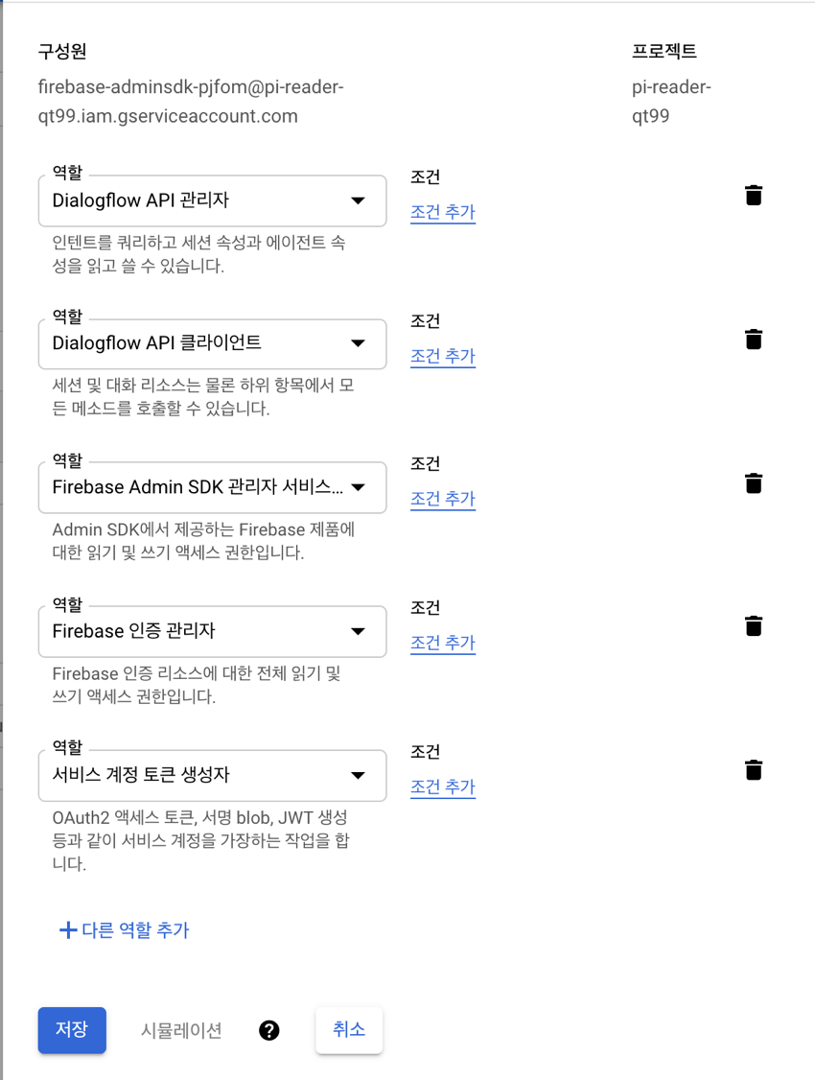

Figure permit to json file in google cloud console

Implementing OCR in the device was considered. There is two popular open-source OCR engine. One is Tesseract (BaekYoungmin, 2019) and the other is EasyOCR (JadiedAI). the tesseract is the most popular open-source OCR engine from 1985. Its architecture is in Figure 33. It needs a wrapper for use in a python file. We use a python wrapper called pytesseract. the output of pytesseract contained not only recognized text but also location. Example output is made by

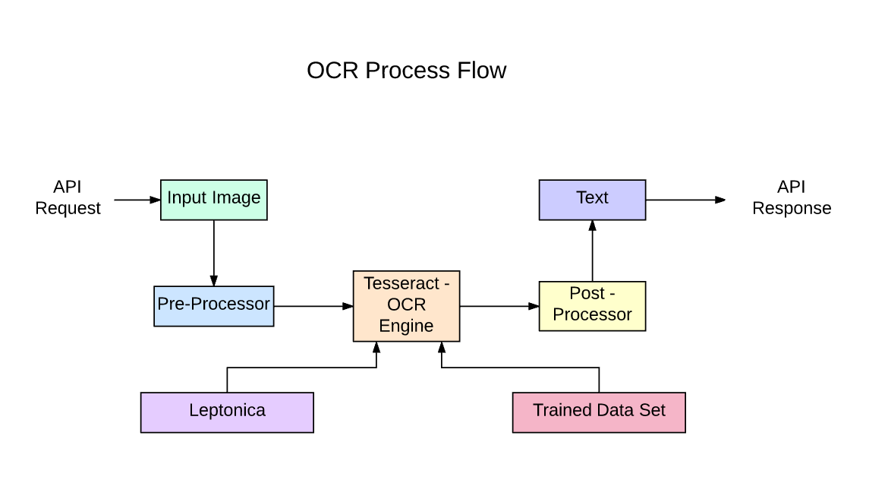

Figure architecture of Tesseract (nanonet)

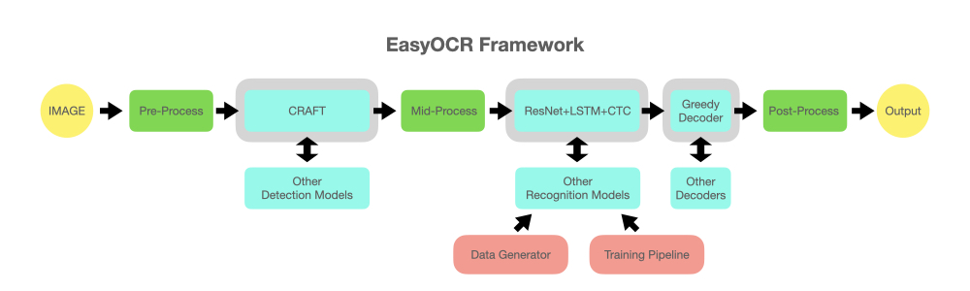

Figure the architecture of EasyOCR (JadiedAI)

both information. easyOCR is open-source ocr engine. It supports many languages including Korean and shows high accuracy. It is divided into two-part. One is text detection and the other is text recognition. In text detection part, It uses the CRAFT algorithm (BaekYoungmin, 2019) which is a powerful text detection model made recently. In text recognition part, CRNN model (Baoguang ShiXiang, 2015) that is simple, potent is used for recognition. Figure 35, Figure 36 is the comparison of both engines.

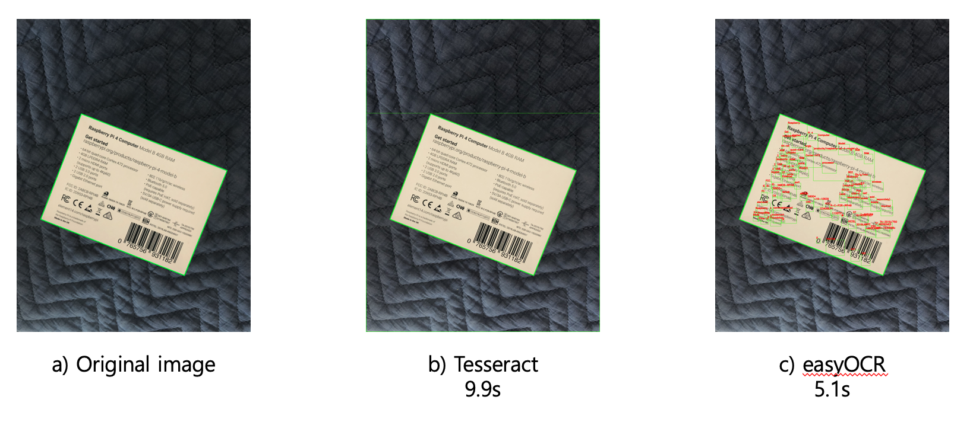

Figure a) original image with Raspberrypi4 box b) tesseract result c) easyOCR result, All executions of code were ran in google colab(Intel(R) Xeon(R) CPU @ 2.30GHz, Tesla P100) (s mean seconds)

The engines with the Raspberrypi box instruction set were compared. The image size is 3024x4032. In Figure 35, tesseract cannot read anything because tesseract has many conditions to meet to use it. Tesseract guides to comply with the following conditions. (tesseract, 날짜 정보 없음)

1. 12pt word size
2. The straight letters
3. Text background processing
4. Split sentence
5. With those conditions, tesseract can show better performance, but it is difficult to always meet the requirements to detect text. Therefore, the result of the original image processed by tesseract does not recognize anything. Otherwise, execute with easyOCR show perfect result. This is because the craft algorithm can detect any location of text.

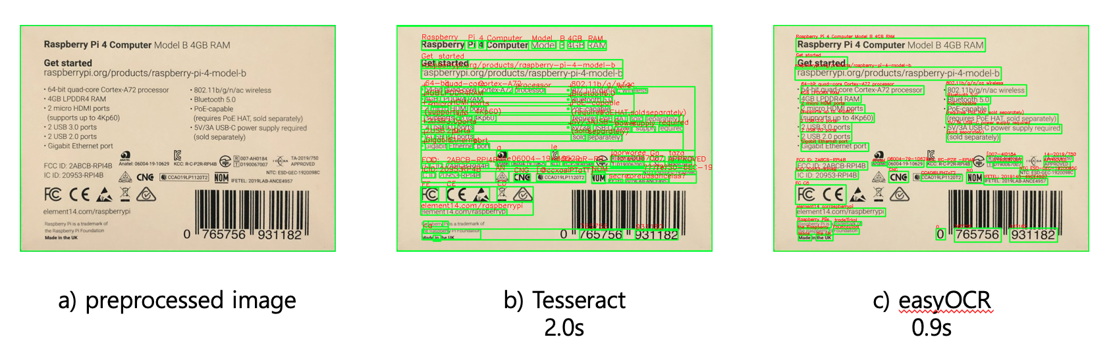

Figure a) preprocessed from original image b) Tesseract result c) easyOCR result, same execution environment with Figure 35, (s mean seconds)

Next is compare Tesseract and easyOCR with the preprocessed image in Figure 36. A, and its size is 674x487. Preprocess was composed of blurring, Canny edge filtering, get contours and find rectangle. These simple filterings make it possible to find rectangle documents. The outcome of preprocessing is Figure 36 b and c. Although easyOCR still shows great performance, tesseract shows a similar result. This means for using tesseract we need a proper module for preprocessing.

Moreover, Tesseract has weakness in not only general text image but also multiple languages. First, the tesseract is trained by synthetic text data from several fonts. Owing to the detail that Fonts were mainly English font, it does not work well on Korean data. If texts in the image are skewed or rotated or fonts are different with tesseract Korean data, results were incorrect.

It seems like easyOCR is faster and better than tesseract. But there is a major drawback in easyOCR. It needs powerful GPU computing. Although it provides quantization and pruning for CPU version, it is very slower than running with GPU. In CPU version, the result was the same, but execution time was 10s in the same image in Figure 36 a. If it is used in an embedded device, using Nvidia Jetson nano should be considered. However, running on Jetson nano takes much more than 30 seconds. Jetson Nano have 4GB vram but easyOCR take more than that, so it is inevitable to allocate swap memory to that. And it makes OCR much slower. If it takes much time to OCR, using google cloud vision api will be the best option.

Google STT service was tested for online STT and Pocketsphinx was tested for offline STT. Pocketsphinx is an open-source offline STT engine. Because Pocketsphinx is quick and lightweight, it is suitable for embedded systems like Raspberry Pi and mobile devices. Although its service can be performed without an internet connection, it does not have a high recognition rate. Google STT is an online STT engine built in Google. Google STT is known to be very accurate and excellent even in a noisy environment.

For the test, three test sentences, which are likely to be used as a voice command, were recorded. Three test lines are as following; “I want you to stop reading.”, “Hi, Pi can you read page number 19?”, and “Can you find the meaning of the word obnoxious?”. Each recorded sentence was tested four times and was evaluated according to how many words were correctly recognized. The following pictures are the first round of the two experiments.

When choosing the STT module, whether to use online or offline module was an issue. If offline engine is used, voice command function can be made without internet connection when appropriate conversation model is implemented. Offline STT models, however, have lower performance than online models. Therefore, accuracy test was taken to find out which engine is more suitable for the project.

Google STT service was tested for online STT and Pocketsphinx was tested for offline STT. Pocketsphinx is an open-source offline STT engine. Because Pocketsphinx is quick and lightweight, it is suitable for embedded systems like Raspberry Pi and mobile devices. Although its service can be performed without internet connection, it does not have a high recognition rate. Google STT is an online STT engine built in Google. Google STT is known to be very accurate and excellent even in a noisy environment.

For the test, three test sentences, which are likely to be used as a voice command, were recorded. Three test lines are as following; “I want you to stop reading.”, “Hi, Pi can you read page number 19?”, and “Can you find the meaning of the word obnoxious?”.

Each recorded sentence was tested four times and was evaluated according to how many words were correctly recognized. The following pictures are the first round of the two experiments.

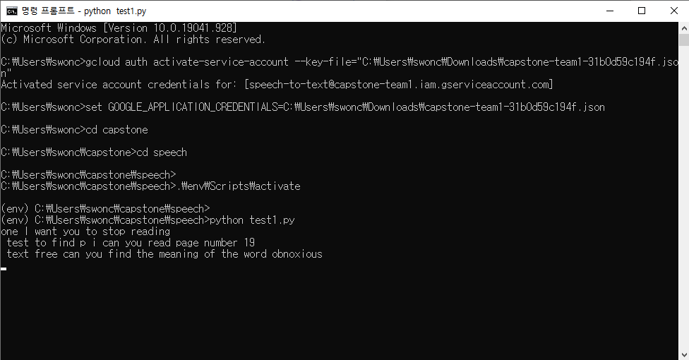

Figure 37 Testing Google STT



Figure 38 Testing Pocketsphinx

|  |  |  |
| --- | --- | --- |
|  | Google STT | Pocketsphinx |
| 1st | 23 / 24 | 8 / 24 |
| 2nd | 22 / 24 | 10 / 24 |
| 3rd | 24 / 24 | 12 / 24 |
| 4th | 23 / 24 | 9 / 24 |
| Total | 92 / 96 (95.8%) | 39 / 96 (40.6%) |

Table 1 Speech recognition test between Google STT and Pocketsphinx

The difference in results was greater than expected. While Google STT correctly recognized almost every word each time, Pocketsphinx failed to exceed 50% of the correct answer. In conclusion, Google STT, which was 55% more accurate, was picked due to its accuracy.

TTS is a core function of the product that transfers text to audio data. Therefore, both online and offline engines will be used to make to product work regardless of internet connection.

Google TTS will be used as an online TTS engine, and it has been tested in a virtual environment. The code below was used to run Google TTS the source of the code came from the Google cloud platform’s GitHub account. Once the code is executed, the input text is converted to an audio file in mp3 format and saved. Experiments on the module showed excellent performance in both English and Korean.

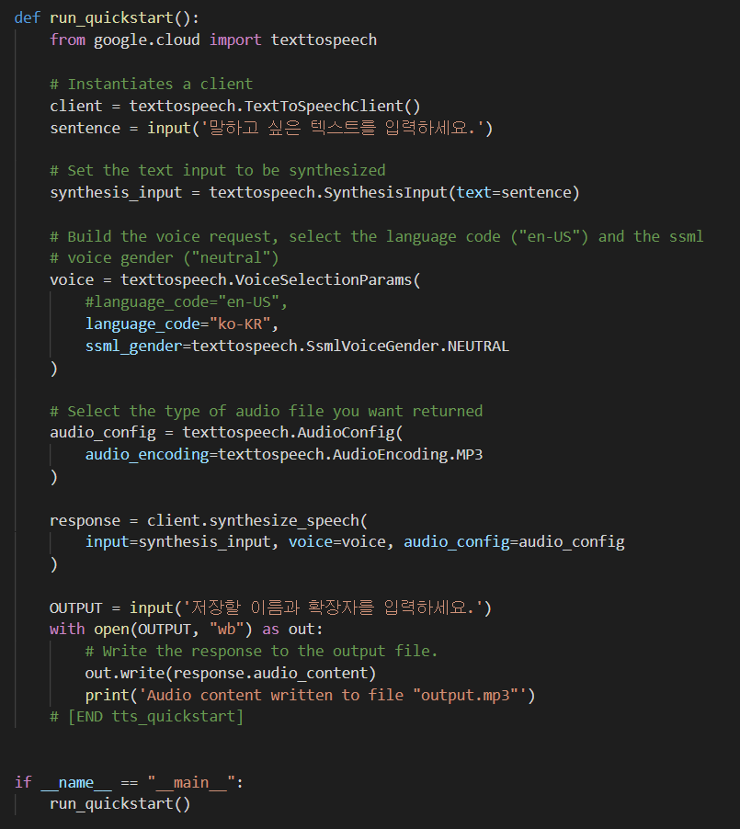

Figure 39 Test Code of Google TTS (GoogleCloudPlatform, 2021)

Offline TTS modules were tested using Espeak. SVOX Pico is also an efficient TTS module, but when converting Korean text to voice it is not efficient. SVOX Pico has to convert Korean using the English alphabet by pronunciation and then input it. Experiments showed that English was fluent enough to read books, but Korean was very unnatural. Thus, whether to only support English in an offline environment is on consideration.

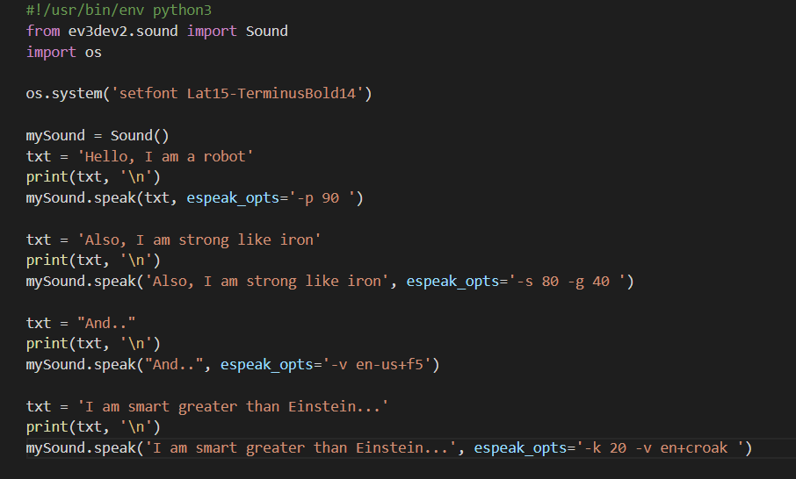

Figure 40 Test Code of Espeak TTS ([EV3-Python] Sound-eSpeak text to speech 사용하기, 2019)

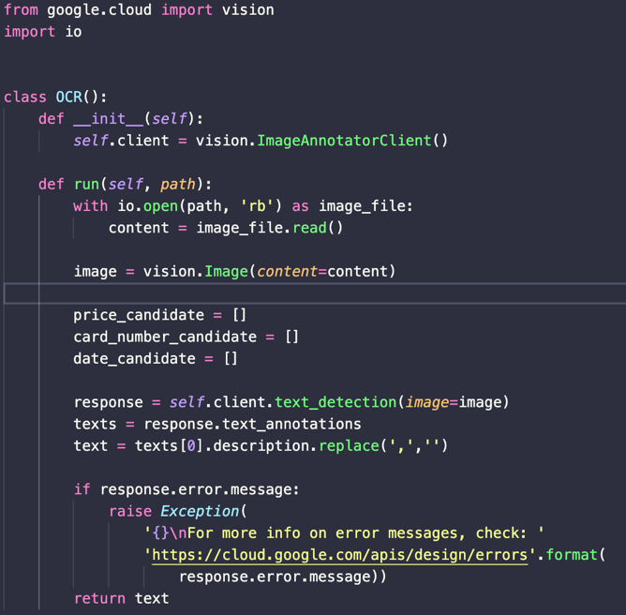 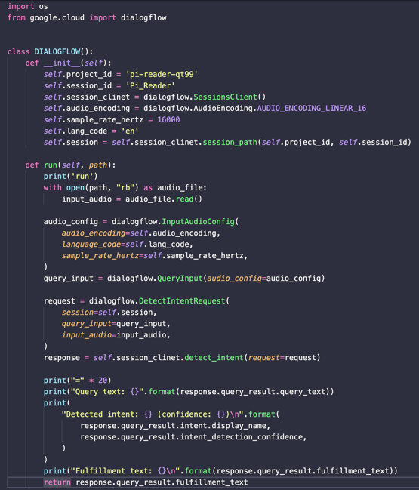

Figure usage of google cloud vision api and dialogflow api

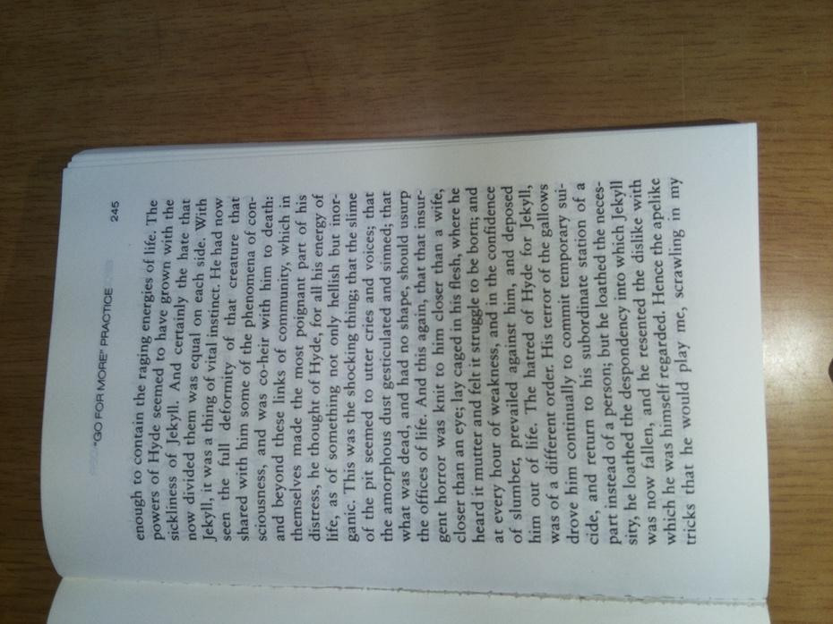 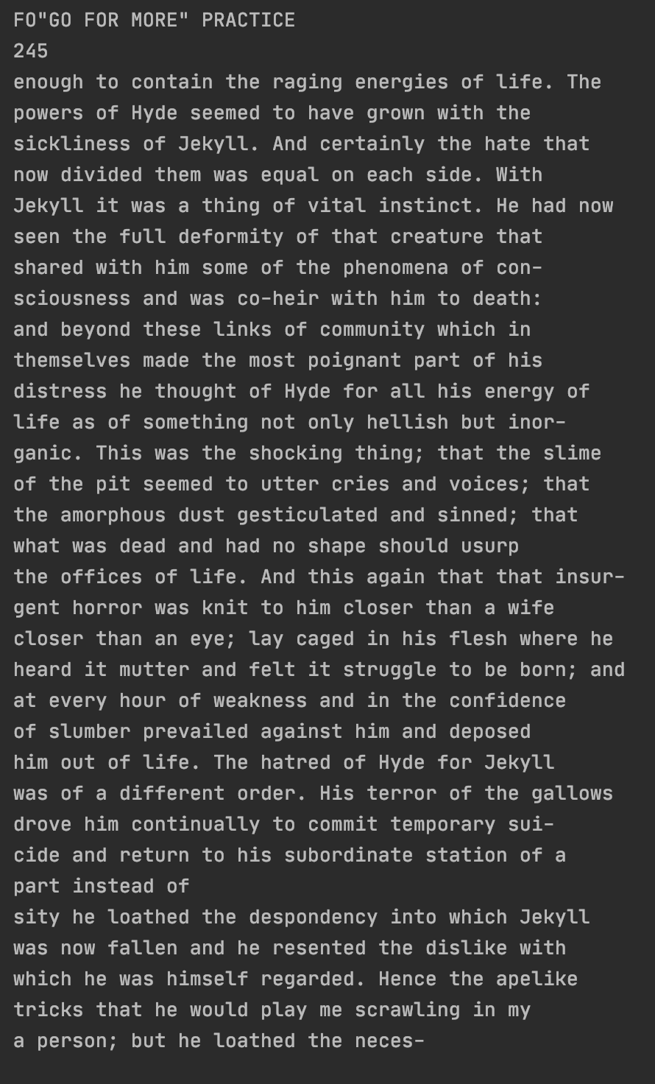

Figure test images captured with picamera and ocr output

Google apis including ocr, tts, dialogflow are used like Figure 41. Their client instance will be initialized when the main class is initialized. And output.jpg in Figure 42 and output.wav which captured and recorded files will read by api instance and they send to google cloud with their protocol. The mainflow of PiReader will be waiting for their response.

## Dialogflow

1. Entity

An entity reflects a word or object applicable to intent and providing a particular content for intent (Google Cloud, 2021). Entity makes it possible for different dialogs to be interpreted same way. For example, when lowering the volume, user can command “lower the volume”, but user can also command “decrease the voice.” To be processed as same way, ‘lower’ and ‘decrease’ should be grouped as a same entity.

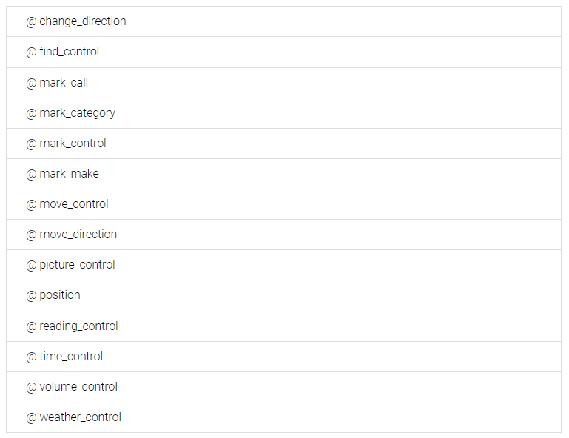

Figure List of entities built for the project

Moreover, although ‘increase’ and ‘decrease’ have the opposite meaning, they should be grouped in a same entity. Even if two words have different meaning, they are used in same way. Both ‘increase’ and ‘decrease’ indicate the direction of the change. if we group entities without considering its usage and only considering its meaning, many unnecessary entities will be created, and it will complicate intent building process. Two opposite words can be grouped in a same entity because entity can hold content.

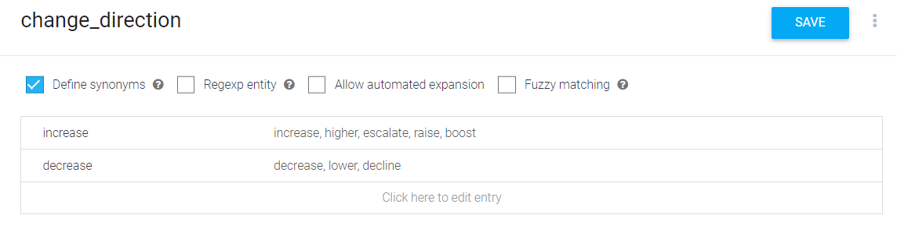

Figure Entity building page in Dialogflow



Figure Entities and its words used in the project

1. Intent

Intent contains logic and element that makes agent to read and answer the users’ requests. When user commands the device, Dialogflow needs to connect comment with built intents. If it fails to connect intent, it should also generate error message. Ten intends were developed in Pi Reader agent and list of intents are shown below.

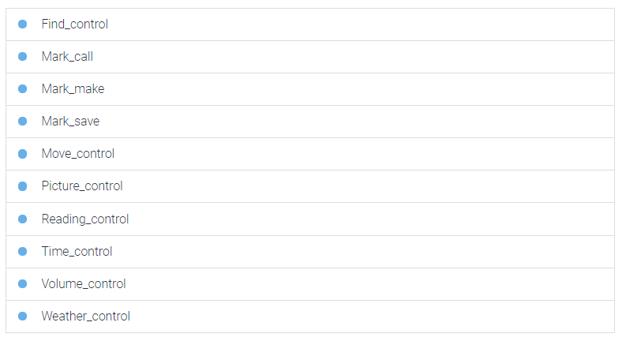

Figure List of intents built for the project

After making the intent and its entities, Training phrases should be added, which are examples of command of following intents. In this case, training phrases are statements that change the volume of the device. After writing the phrases, words that holds content of entity should be grouped. In this case, brown highlight is a group of change_direction entity. When training phrases are made, Dialogflow automatically trains the agent with its machine leaning technology.

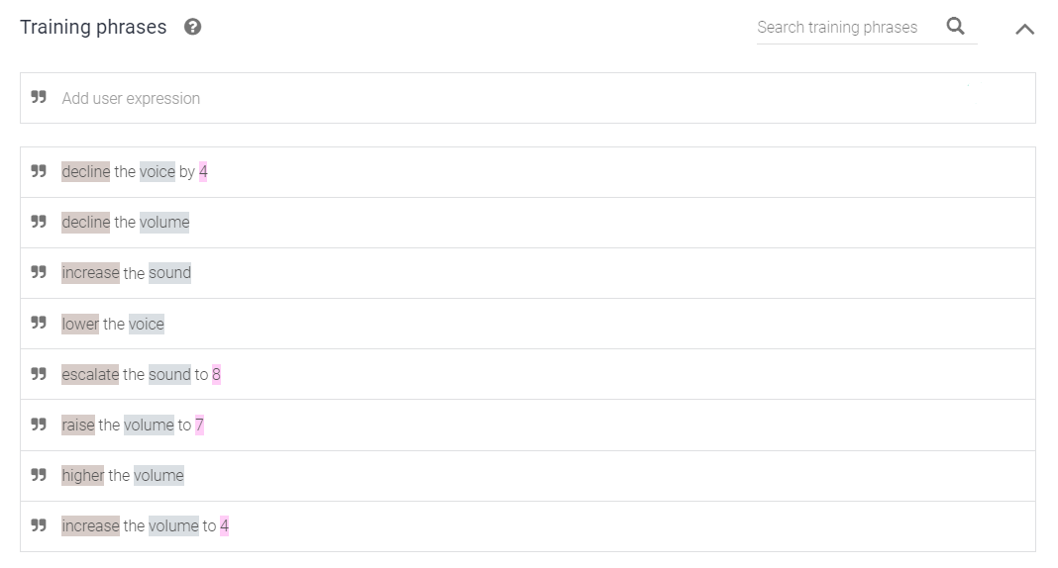

Figure Intent making process – training phrases

1. Fulfillment

There were two ways for Raspberry pi and Dialogflow to interact. One is using firebase and the other is using fulfillment text. Both methods can be implemented in the inline editor in Dialogflow. Below is comparison between two methods.

|  |  |  |
| --- | --- | --- |
| Methods | Using firebase | Using fulfillment text |
| Workflow | Dialogflow (process data)-> firebase  -> Raspberry pi | Dialogflow -> Raspberry pi (process data) |
| Characteristics | Dialogflow processes the data. | Raspberry pi processes data |
| Advantages | 1. Raspberry pi can just read data.  2. Raspberry pi do not need to send data back over the internet | 1. Do not need to use while loops because fulfillment text only generates when there is new command.  2. Because there is no extra connection between Dialogflow and Firebase, it is much faster. |
| Disadvantages | Loops of while() function should be used to detect change made in the firebase and it may act as a burden of the processor. | In some functions, Raspberry pi should send data back to the internet. |

Table comparison between two fulfillment methods

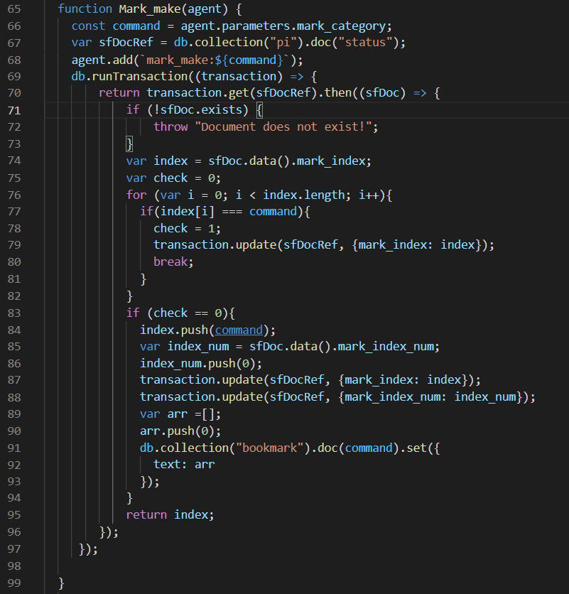

Figure mark_make function when using firebase

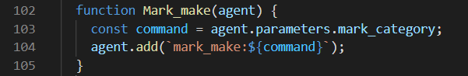

Figure mark_make function when using fulfillment text

Most distinguishable factor between two methods is that for some functions, when using fulfillment text, Raspberry pi needs extra connection to the internet. For example, when using mark make function, which is category making function. Processor has to check the list of bookmark category to find out if there is already a category with same named. As a result, when fulfillment text is delivered from Dialogflow, Raspberry pi needs to send data back to firebase and therefore, this method needs extra connection. Because functionalities of two methods were same, we tested completion time of four functions for each method. Those four functions are: pause_control, volume_control, make_control. save_control. Former two functions do not need extra connection for fulfillment text method but latter two does. Each function was tested 5 times and result shows average value.

|  |  |  |  |
| --- | --- | --- | --- |
|  | Using Firebase | Using fulfillment text | Difference |
| Pause_control | 3.4 | 2.2 | +1.2 |
| Volume_control | 3.4 | 2.1 | +1.3 |
| Make_control | 3.1 | 3.2 | -0.1 |
| Save_control | 3.5 | 3.7 | -0.2 |

Table Test of two methods

When using firebase, make_control and save_control were faster by 0.1 and 0.2 seconds but pause_control and volume_control were slower by 1.2 and 1.3 seconds. This result not only means that extra connection between raspberry pi and firebase did not significantly affect completion time, but it also means that data processing in Dialogflow took longer than data processing in Raspberry pi. Pi Reader used fulfillment text as a fulfillment method.



Figure Intends used in Pi reader

Ten intents were created to fulfill Pi Reader’s diverse functionalities. Table above contains all the information including used entities, description, and its fulfillment text.

## Firebase

1. Design Cloud Firestore database

In order to implement bookmark function, it is necessary to design suitable Cloud Firestore database. Therefore, before designating database, it was preceded by considering bookmark tasks that require DB transaction. There are three bookmark tasks.

* 1. Bookmark tasks
     1. Calling the bookmark

A task that calls a bookmark, which requires information from the category of the bookmark that it wants to call, and the number of page that want to start the call.

* + 1. Saving contents in certain bookmark category

A task that stores the contents of a page in a particular category in DB, requiring information about the category in which the content will be stored.

* + 1. Making bookmark category

A task for creating a bookmark category, which requires information about whether or not the category exists in the DB.

After analyzing these three bookmark tasks, the DB schema was planned with the part that stores the status information of the bookmark task in real time and the part that stores the categories containing the bookmarked contents. The completed DB schema is as follows.

* 1. Cloud Firestore DB schema

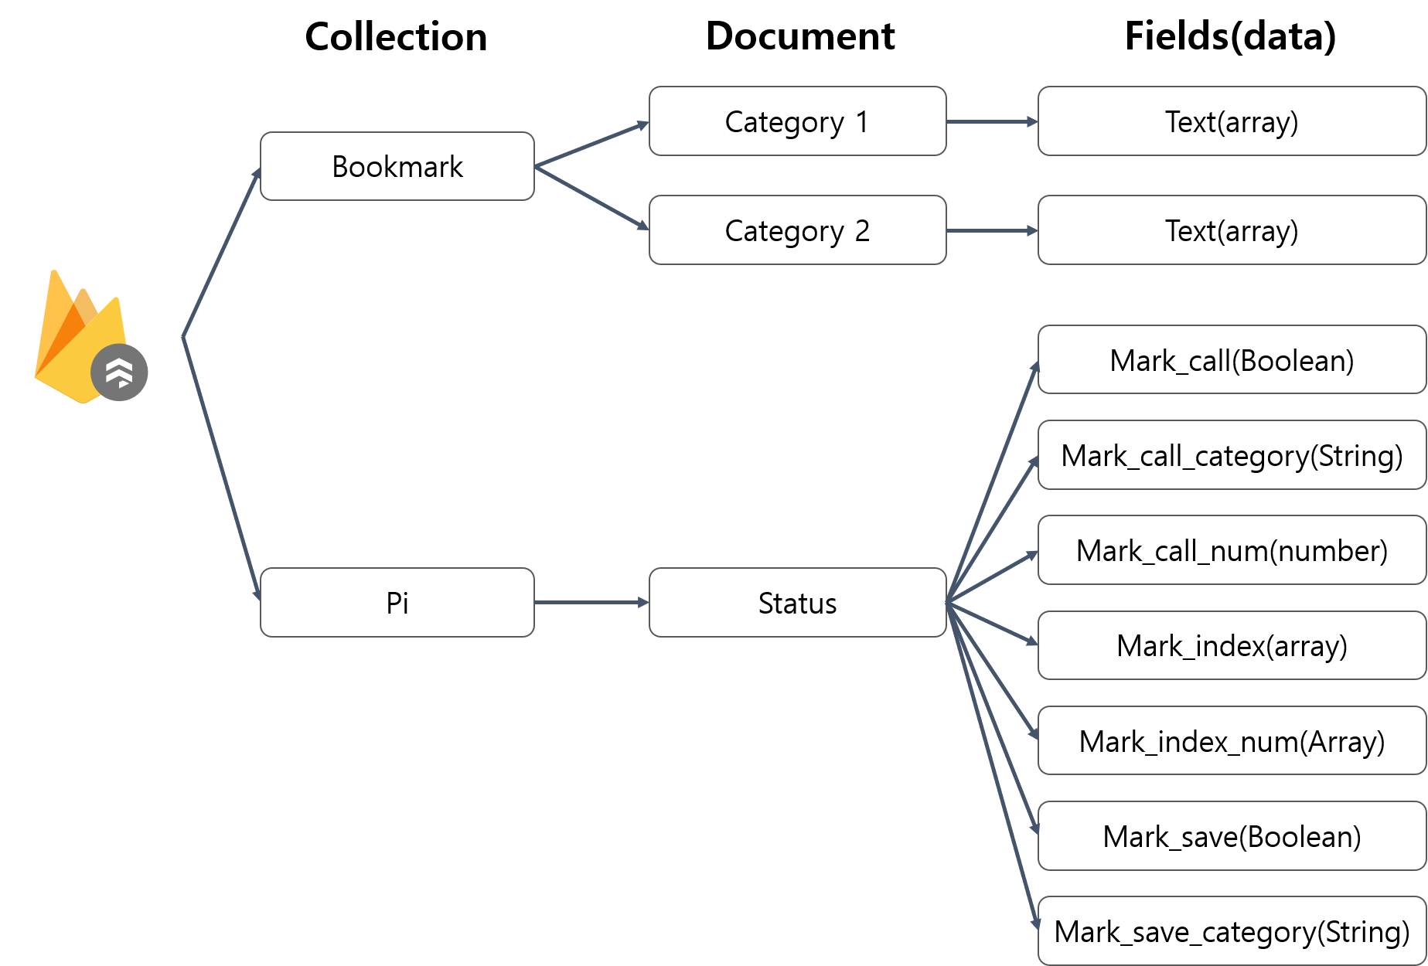

Figure Cloud Firestore DB schema

There are two collections in Cloud Firestore DB. Several categories created by the user’s making bookmark category command are contained in “Bookmark” collections. Category is stored in document formatt and it is distinguished from other categories by its own document name. Each category document contains array value which key’s name is “Text”.

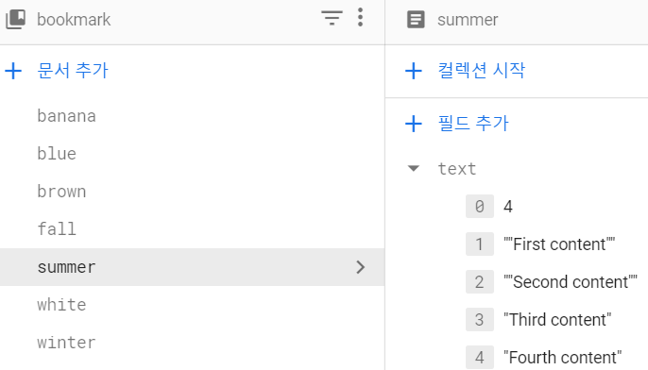

Figure “Text” field in summer category

The first element(value in index 0) in array is the value that stores the number of pages in the current category. When a category is created, it defaults to zero. If bookmark content is stored in the category, the bookmark content stores in the element after zero index sequentially, and array’s first element’s value increases as the number of bookmark page increases.

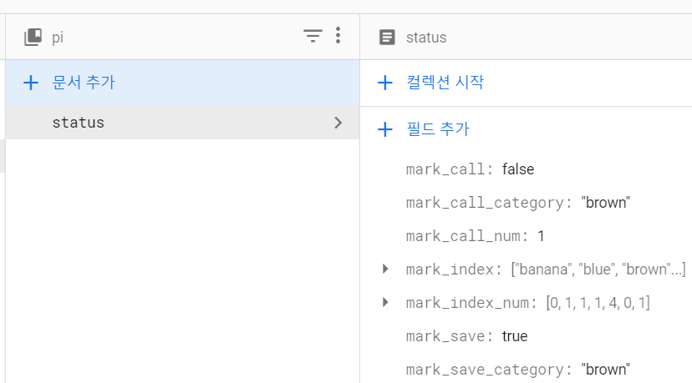

Figure Data fields in status document

“Pi” collection contains “status” document which stores the progress of the bookmark-related tasks and the status information of each saved category. Each field’s detailed description is as follows.

|  |  |  |
| --- | --- | --- |
| **Field name** | **Value type** | **Information** |
| Mark_Call | Boolean | Whether bookmark call task is in progress or not |
| Mark_call_category | String | Category most recently called |
| Mark_call_number | Number | Page number called in Mark_call_category field |
| Mark_index | Array | Array containing category’s name |
| Mark_index_num | Array | Array containing each category’s total page number |
| Mark_save | Boolean | Whether bookmark save task is in progress or not |
| Mark_save_category | String | Category that recently mark save task is executed |

Table Data fields in status document

When bookmark call task is in progress, Mark_Call field’s value is True. As soon as bookmark call task is finished, Makr_call field’s value is changed into False. In Mark_call_category field and Mark_call_number field, if the bookmark call task for the new category is executed, the value of the field is changed.

Mark_index field contains all category names in “bookmark” collection and Mark_index_num contains each category’s total page number in the same order as Mark_index field. When new category is made or number of page is increased, these fields’ values are changed.

When bookmark save task is in progress, Mark_save field’s value is True and it is changed into False when bookmark save task is finished. In addition, if new bookmark save task is executed, the category used in the bookmark save task becomes the Mark_save_category’s value.

1. DB transaction for Bookmark tasks

There are three bookmark tasks. The one is bookmark call, another is bookmark save and the other is make bookmark category. DB transaction for the bookmark tasks are as follows.

* 1. Bookmark call

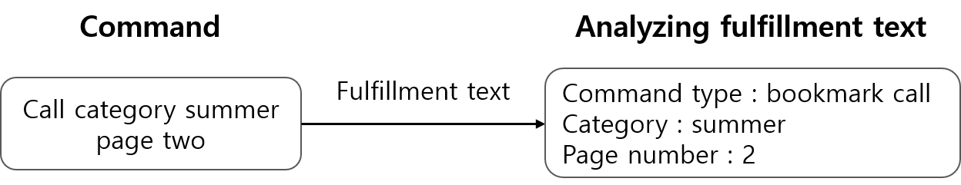

Figure Extracting bookmark call information

Before sending db query request to firebase, it is necessary to extract user’s bookmark command information in dialogflow’s fulfillment text.

Provide that user’s voice command is “Call category summer page two”. After intent matching process in dialogflow, fulfillment text is sent to Raspberry pi. Through this fulfillment text, Pi recognizes that this command is bookmark call command. After analyzing fulfillment text, raspberry pi sends db query for calling bookmark contents

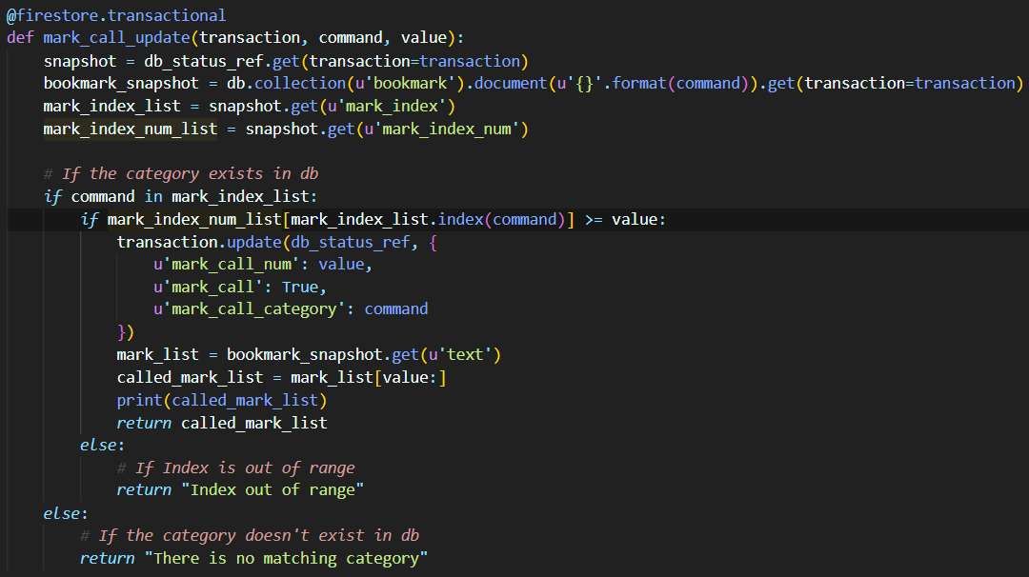

Figure mark call command db transaction code

The db transaction via db query is carried out by the following steps in detail.

* + 1. Snapshot current db state.

To check the current database, snapshot current db state.

* + 1. Check whether called category exists in db or not.

If category doesn’t exist in db, return Error message “There is no matching category” and terminate db query. If category exists in in db, db transaction goes on consistently. In this example, “summer” category is in db in document format.

* + 1. Check whether page number is out of index in “text” field array.

If page number is out of index range in “text” field array, return Error message “Index out of range” and terminate db query. If the page number isn’t out of index range, db transaction goes on consistently. In this example, requested page number is 2 and array’s index in “text” field in “summer” category is 4. As a result, the page number isn’t out of index range.

* + 1. Update db status, get bookmark content and return query result to Raspberry pi.

Update fields related with mark call task in “status” document.

“mark_call”: True, “make_category” : summer, “mark_page_num”: 2

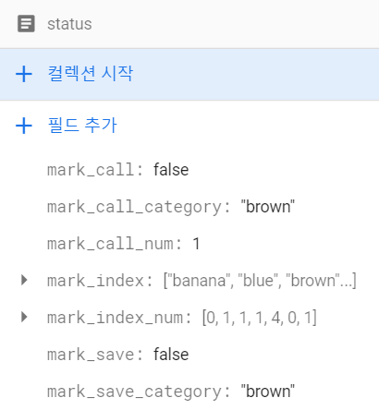

Figure Fields in “status” document(before)

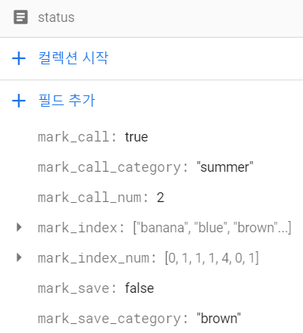

Figure Fields in status document(after)

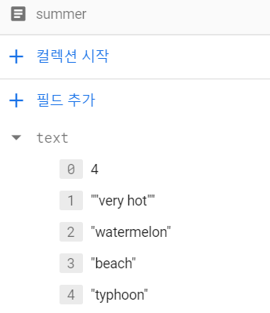

Figure Text Field in “summer” category

Get contents using page number. In this example, page number is 2, so bring all bookmark contents from index 2 in “text” array. Using this bookmark content, make string that distinguish each bookmark content with comma. In this case, string is “watermelon, beach. typhoon”. After making string, return this string to Raspberry pi. When bookmark call task is done, set the mark_call field value to “False”.

* 1. Bookmark save

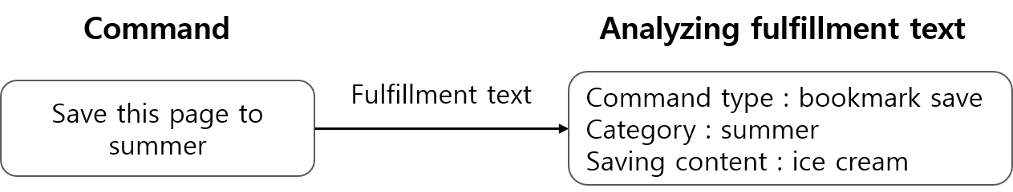

Figure Extracting bookmark save information

Providing that user’s voice command is “Save this page to summer”. Using fulfillment text from dialogflow, Pi recognizes that this command is bookmark save command. After analyzing fulfillment text, raspberry pi sends db query for calling bookmark contents. In this example, to make it easier to express situation, provide this page’s content(saving content) is “ice cream”.

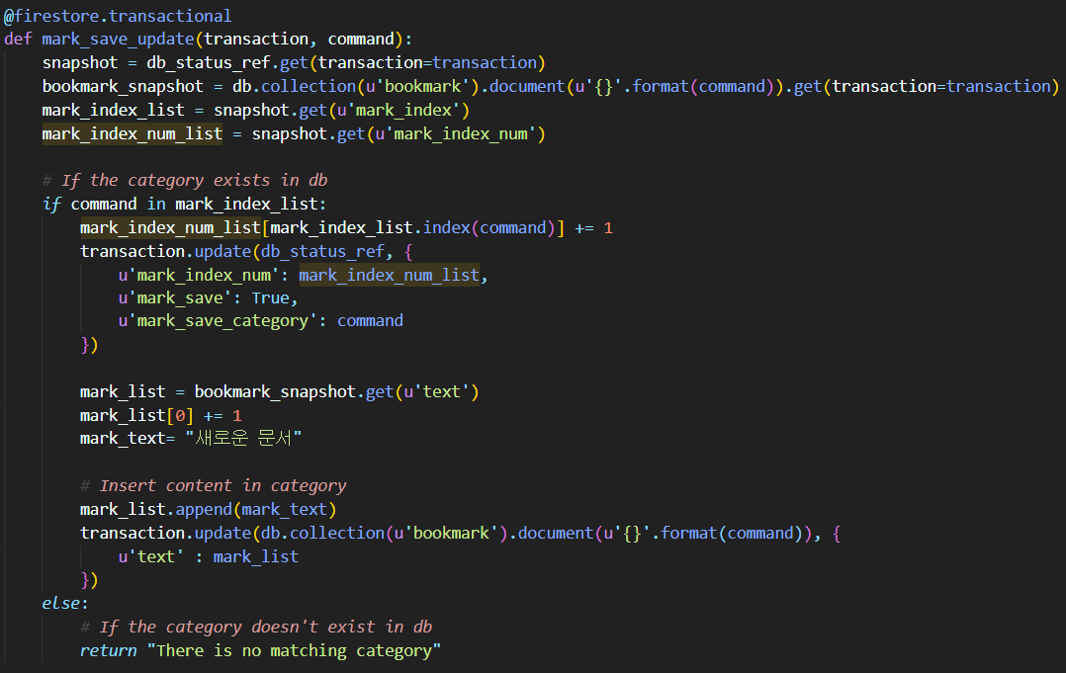

Figure mark save command db transaction code

The db transaction via db query is carried out by the following steps.

* + 1. Snapshot current db state.

To check the current database, snapshot current db state.

* + 1. Check whether called category exists in db or not.

If category does not exist in db, return Error message “There is no matching category” and terminate db query. If category exists in in db, db transaction goes on consistently. In this example, “summer” category is in db in document format.

* + 1. Update fields in “status” document.

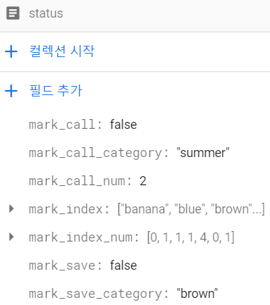

Figure Fields in “status” document(before)

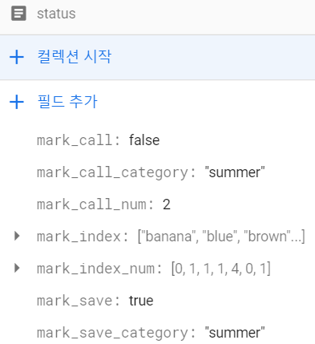

Figure Fields in status document(after)

Update fields related with mark save task in “status” document.

“mark_call” : True, “mark_save_category” : summer

* + 1. Add bookmark content to “text” array field in “summer” document. Update mark_index_num.

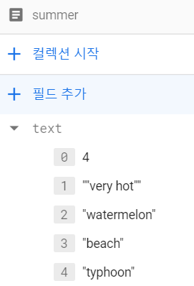

Figure Field in “summer” (before)

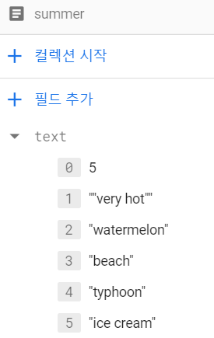

Figure Field in “summer” (after)

Add bookmark content “ice cream” to text array field. In this case, the first element in array which represent page number in category increases by 1. In addition, update mark_index_num which contains number of page for each category. In this case, the page number of “summer” is increasing from 4 to 5. Therefore, mark_index_num’s value corresponding “summer” category is update to 5. When bookmark save task is done, set the mark_save field value to “False”.

* 1. Make bookmark category

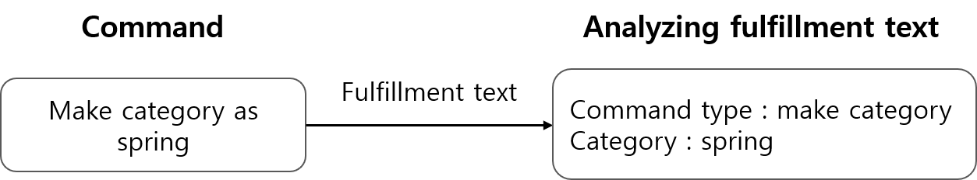

Figure Extracting make category information

Provide that user’s voice command is “Make category as spring”. After analyzing fulfillment text, raspberry pi sends DB query for calling bookmark contents.

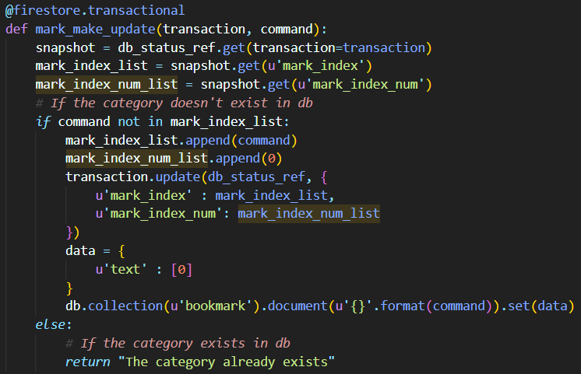

Figure make category command db transaction code

The db transaction via db query is carried out by the following steps.

* + 1. Snapshot current db state.

To check the current database, snapshot current db state.

* + 1. Check whether called category exists in db or not.

If category is in db, return Error message “The category already exists” and terminate db query. If category exists in in db, db transaction goes on consistently. In this example, “spring” category isn’t in db in document format. Hence, continue db query.

* + 1. Add category in bookmark collection and update fields in status document.

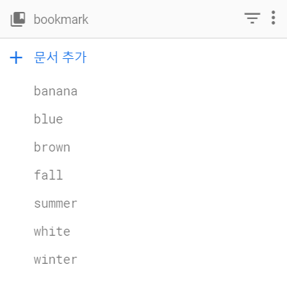

Figure Documents in bookmark(before)

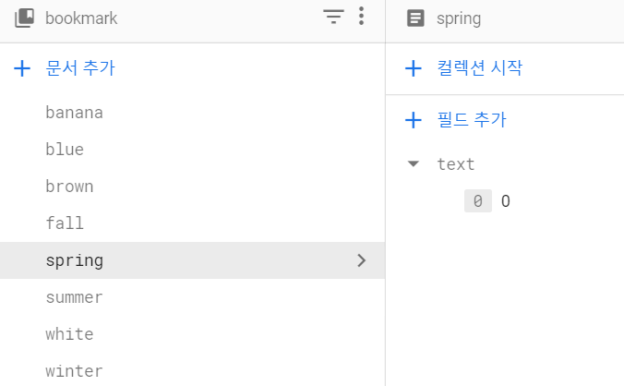

Figure Documents in bookmark(after)

Add category “spring” in bookmark collection. At this time, make “text” array field of which first element’s value is set to 0.

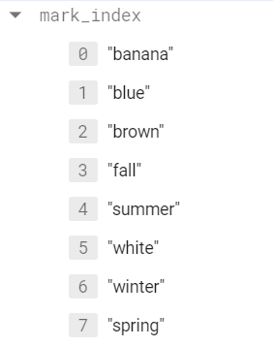

Figure Update mark_index field

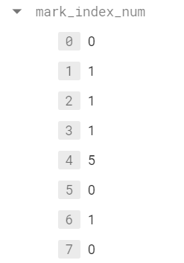

Figure Update mark_index_num field

In order to store current category list, update mark_index field to add “spring” element. In addition, add spring category’s page number to mark_inex_num field.

## Device

With Raspberry Pi, 2 membrane switch, and Picamera v2, headset with the sound card and battery modules are used.

1. Switch

The switch is for easier use of volume control and reading and play/pause. 2 switches are used for volume, reading / play&pause. Also, add jumper cable to control device easier and use gpiozero library for interpreting press in button. With gpiozero, it is easy to receive input through gpio while the spinning process will check whether the button is pressed.

1. Picamera v2

Picamera is well-made camera that for an embedded device. It has a maximum 3280 x 2464 resolution and it is good enough for our purpose. Moreover, picamera package is provided through pip. Initialize camera with provided picamera Class and using capture method to capture easily. However, there is the disadvantage of it. Picamera cannot change focus. Producers have to adjust the cross shape beside the lens to change focus. Pireader is set to mainly focus on from 25cm to 50cm. This distance is determined by the device’s arm which makes maximum, minimum distance.

1. Headset & soundcard

The headset is proper to use in PiReader. Voice command may blend with output sound in PiReader. Therefore, Sound input and output should be divided. Also, PiReader uses ALSA which is Linux sound kernel module. With ALSA it is possible to use pyaudio and pygame package. Each of them is for audio input and output. Additionally, using pyaudio and pygame sound configuragtion file(.asoundrc) is needed. PiReader uses USB soundcard because of the absence audio input soundcard in raspberry pi, configuration is set to usb input and output.

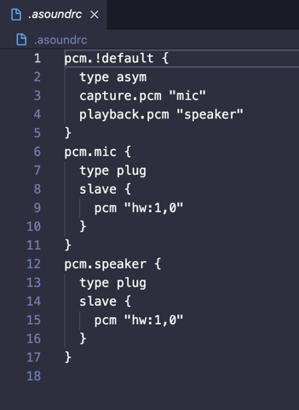

Figure The sound configuration file of PiReader

1. Battery module

Battery module make PiReader portable. It connected under the raspberrypi board and send power through under gpio pin. Pressing the blue button make raspberrypi with the battery module to turn on.

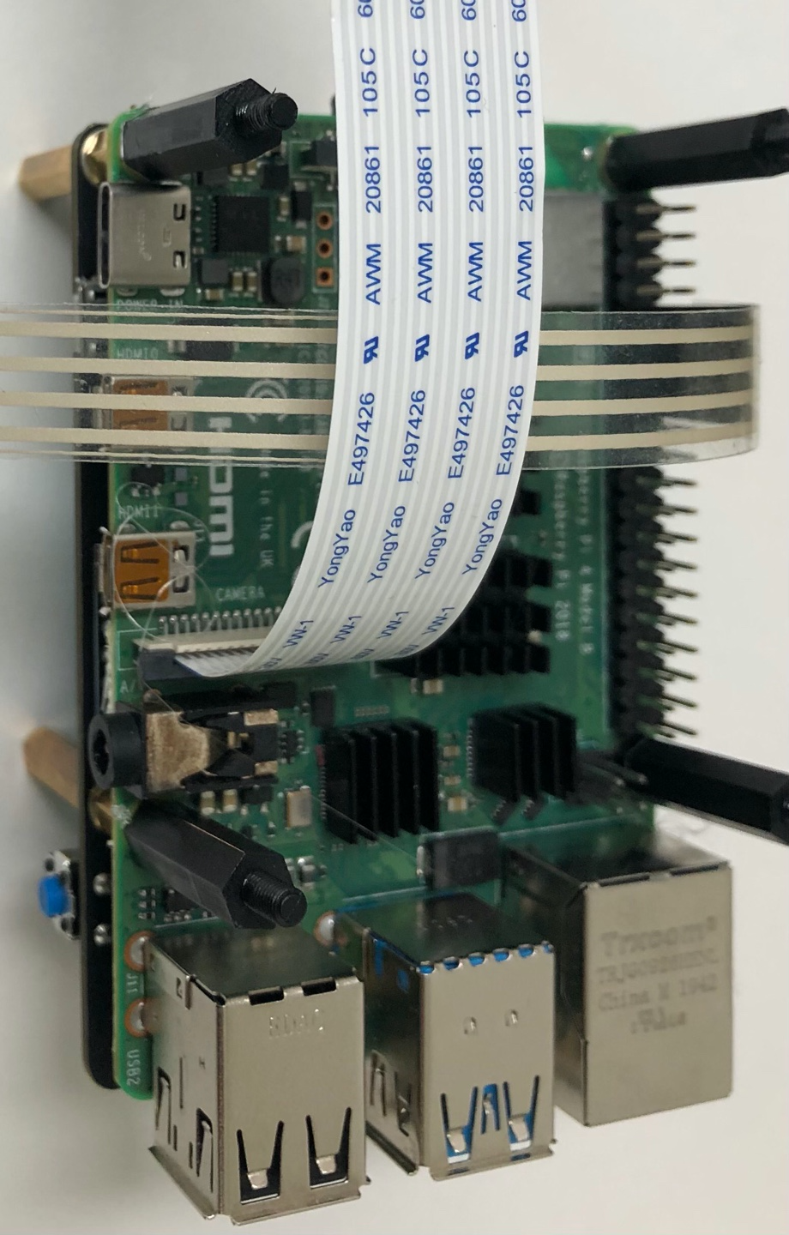 

Figure raspberrypi board that is connected with battery module

## 3D modeling

As for hardware, the project needed the case for the device which is easy and safe for visually impaired to use. The case should protect the device from danger from outside. Also, to improve portability and physical stability, a holder for device should be designed. Therefore, the project concluded to use 3d printer and design a case and a holder for the device. There are some constraints on a case and a holder.

1. A case should be fit with the device.
2. A case could be attached to a holder.
3. A case should have holes for cooling the device.
4. A case should protect the device from outer damage.
5. A holder should be light.
6. A holder should be easy to install.
7. A holder should help user locate documents at proper location.
8. A holder should hold the device while reading so that users do not have to hold the device by their hands.

Considering these constraints, a case and a holder’s design were concluded as follows.

1. The case
   1. Fit with the device, cooling the device, attaching the device to the holder

To fit with the device, size of the case and locations of holes should be considered.

* + 1. Size of the case

There are some existing free designs of Raspberry pi case. However, the device contains not only Raspberry pi but also a battery module and a camera module, the existing designs of the case could not be used. Therefore, size of the device was gotten by measuring the device including the battery module and the camera module.

Width of the case: 91mm

Length of the case: 57mm

Height of the case: 52mm

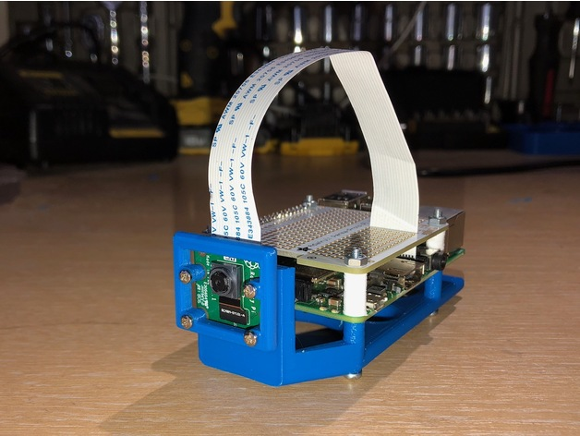

Figure existing design of the case

* + 1. Locations of holes

There were several buttons and charging terminals in the device which could be reached by making holes on the case. Plus, holes to fix the case with the device and a hole for the camera module were needed. Holes for the SD card and for attaching the case to the holder also should be implemented.

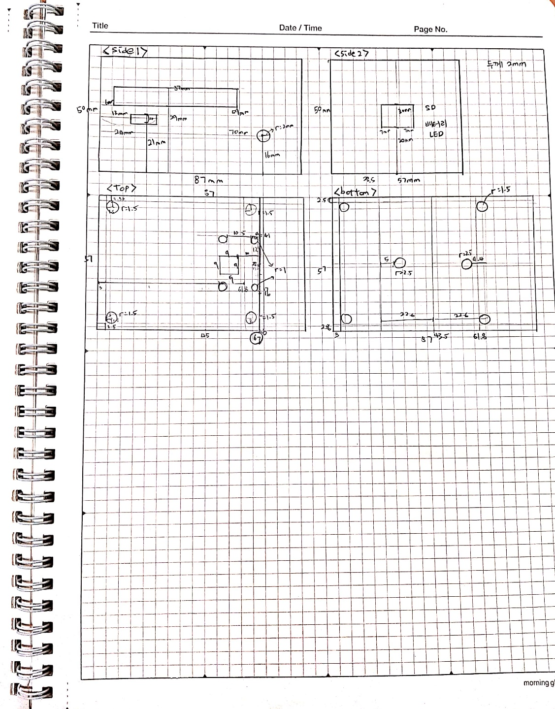

Figure design for the case

Side1 contains holes for a charging terminal, power button and several terminals such as a 3.5mm speaker terminal. Side2 contains a hole for SD card. Top contains holes for cooling the device, the camera module and fixing the case to the device. Bottom has holes for attaching the case to the holder and fixing the case to the device.

* 1. Protect the device

To protect the device from outer danger, design the case to have thickness 2mm.

1. The holder

Since the weight of the device was heavy to hang on users’ neck, additional holder to hold the device should be designed. The holder should be light enough to carry around and easy to install anywhere users want. Plus, designs to locate the device and documents properly should be considered since some users are visually impaired.

* 1. Portability, easy to install
     1. Tripod

Small tripods are easy to carry around and easy to install since users can use it by just unfold the legs. There were some free shared 3D designs where the device can be attached.

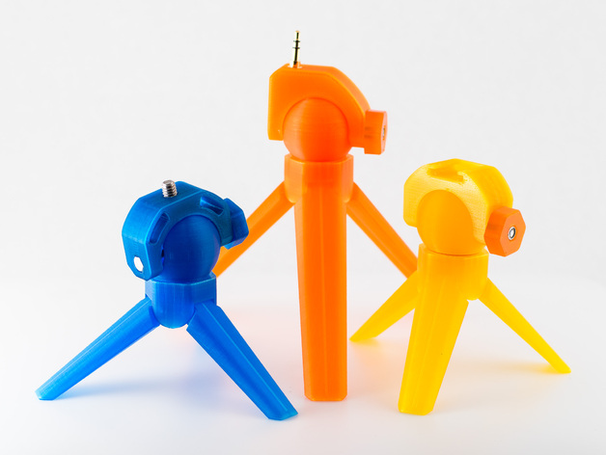

Figure free shared tripod design

The OCR gives the best result when the picture is taken vertically. However, it was hard to redesign the tripod to hold the device vertically with the document. Therefore, tripod could not be used for the holder.

* + 1. Smartphone holder

Smartphone holders were easy to bend and rotate so that can hold the device vertically with documents. Also, there are easy to carry and install to the desk using a clamp.

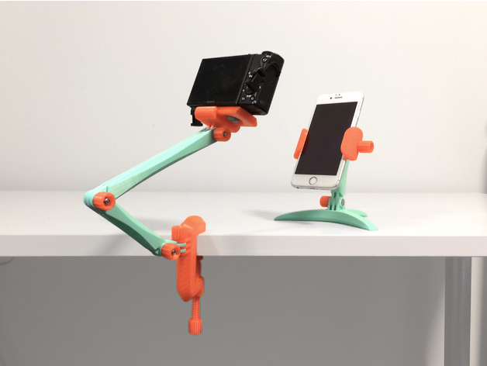

Figure free shared smartphone holder design

By modifying the length of the holder arms, locating the device to get proper images. Therefore, the smartphone holder was chosen to become the holder of the project.

* 1. Locating the device and documents
     1. Fixing the height

The height of the device should be fixed to get clear image because Pi Cam V2 does not have autofocus feature. Therefore, set focus was led to fixing the distance between the device and the documents. To implement constant distance, the height of the device should be settled.

Considering the angle of view of the Pi Cam V2 module, the minimum distance could be calculated.

Pi Cam V2 8MP angle of view: horizontal 62.2°, vertical 48.8°

Length of arm: 230 mm

A4 size: 210 mm x 297 mm

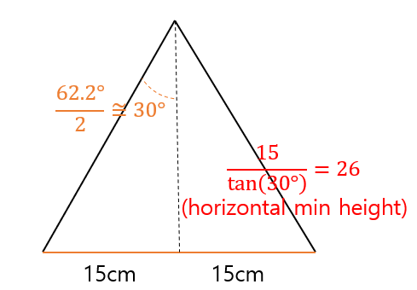

Figure horizontal minimum considering horizontal angle

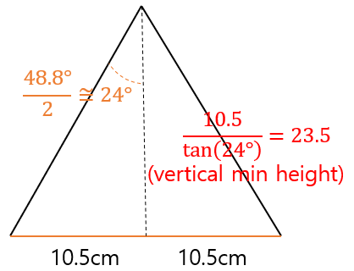

Figure minimum height considering verical angle

Considering the calculation result, set the distance between the camera and documents as 30cm is reasonable. Since the height of the case is about 5cm, set the height of the device as 35cm. To get the device’s height as 35cm, the angle between two arms of the holder should be fixed to certain angle. Calculation was done assuming documents’ size are the same as A4 size. Since most of books’ size are smaller than A4, the height is also enough to read books.

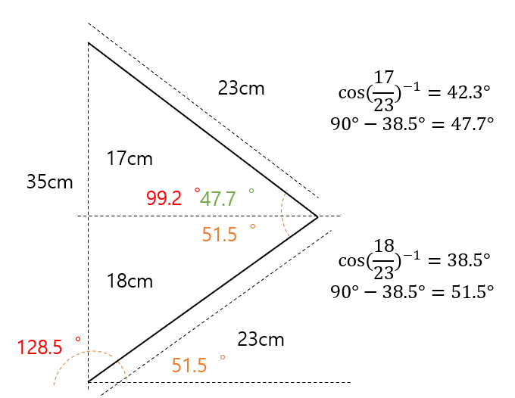

Figure calculating angles between the arms

Maximum length of the arm is 23cm due to the size limit of 3D printer. Therefore, assuming the length of arms as 23 cm, height of the device as 35cm, the angle between the first arm and the clamp is $128.5°$ and the angle between the second arm and the first arm is .

* + 1. Fixing the location of documents

Since the height of the device was get assuming documents are located right under the device, there should be a design to fix the location of document. Visually impaired can put documents in proper place by using the part. Because A4’s is 210 x 297 mm, making the holder as grid shape whose size is 1/3 size of A4 is reasonable.

* 1. Total design

Considering portability, easy installing, proper distance, and angle for image taking and fixing location of document, total design of the holder was concluded as shown in Figure 80.

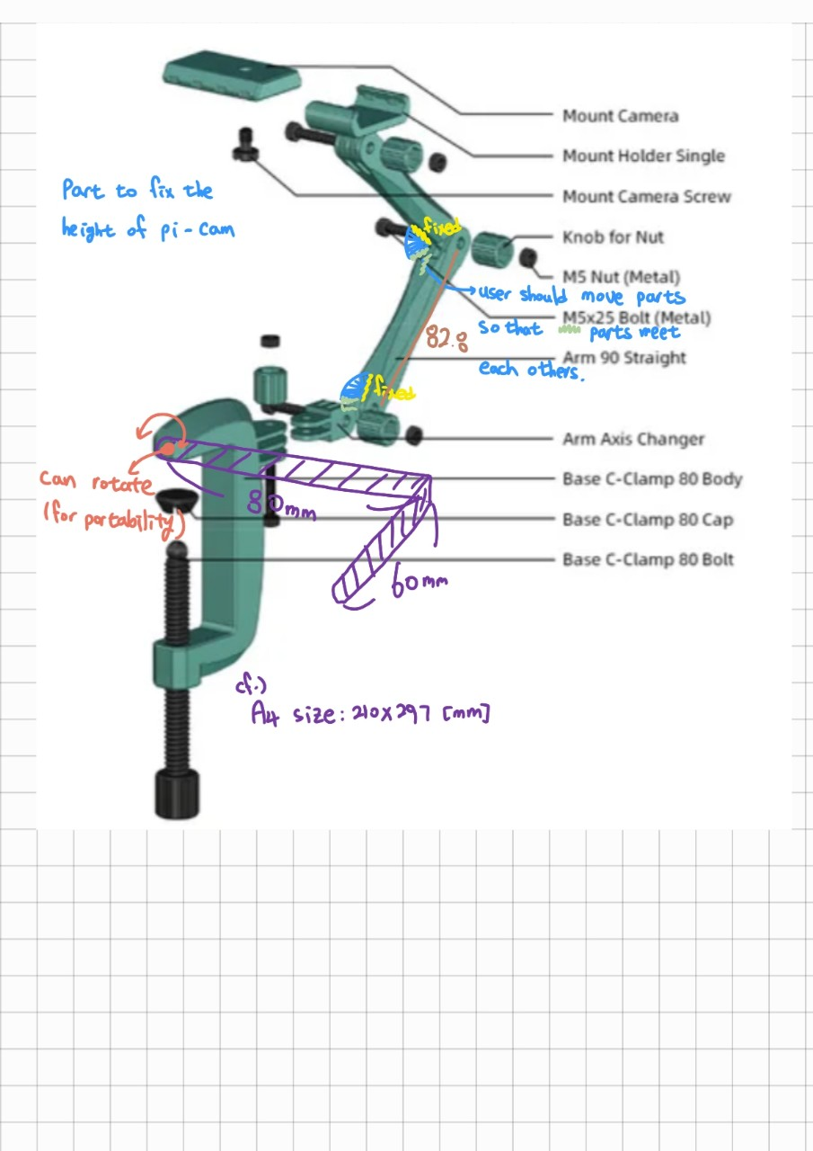

Figure modifying the smartphone holder

1. Design the model by SketchUp

Using a open 3D modeling software SketchUp, making the case and the holder following the design was done.

* 1. Case

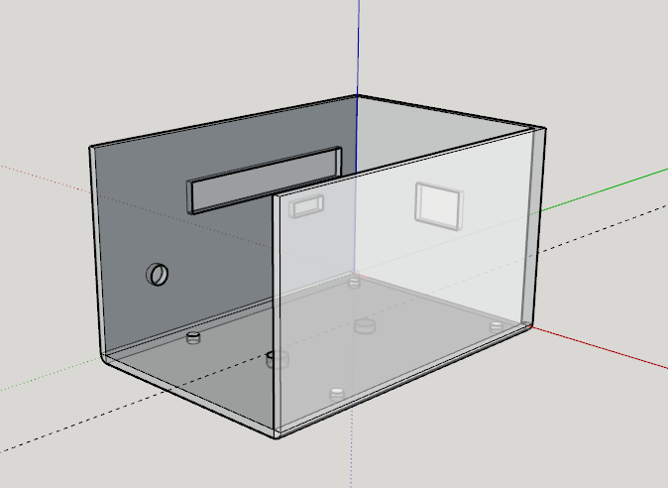 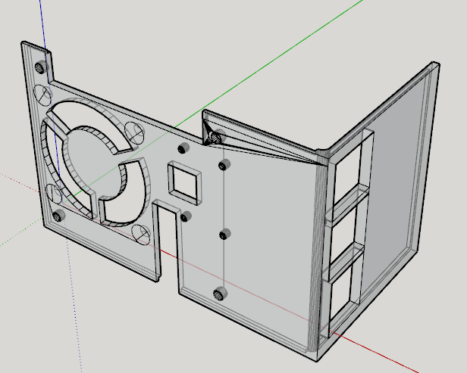

Figure case: bottom & top

Bottom part contains the SD card hole, the several terminals’ hole, the power button’s hole, the charging terminal’s hole, the holes for fixing the case and the device and fixing the case and the holder. Top part contains the colling holes, the USB terminals’ holes, the Len port’s hole, the camera’s hole and holes to fix the camera module and the holes for fixing the case and the device.

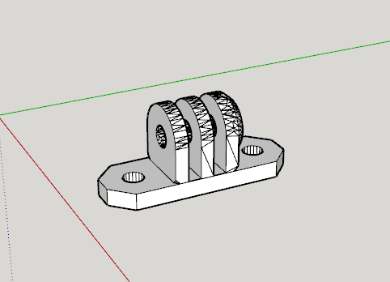

Figure connector between the case and the holder

The connector can be attached to the case by screws and attached to the holder by a bolt and a nut.

* 1. Holder

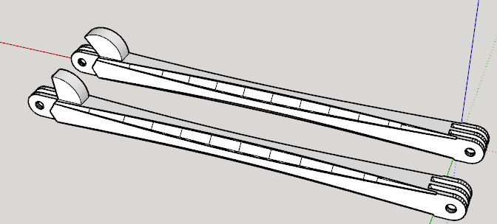

Figure arm1 & arm2

Length of arms are 23cm. Arm1 has a part to fix the angle between the clamp and arm1 whose angle is $128.5°$. Arm2 also has a part to fix the angle between Arm1 and Arm2 whose angle is $99.2°$.

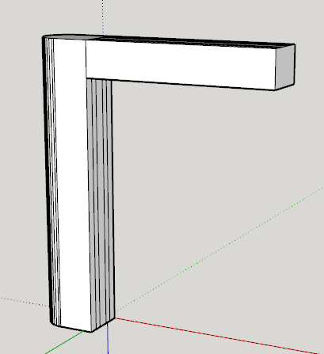

Figure document locator

Document locator is for locating documents right below the camera. The height of the locator is 80mm and the width is 60mm when measured inside.

* 1. Total Hardware

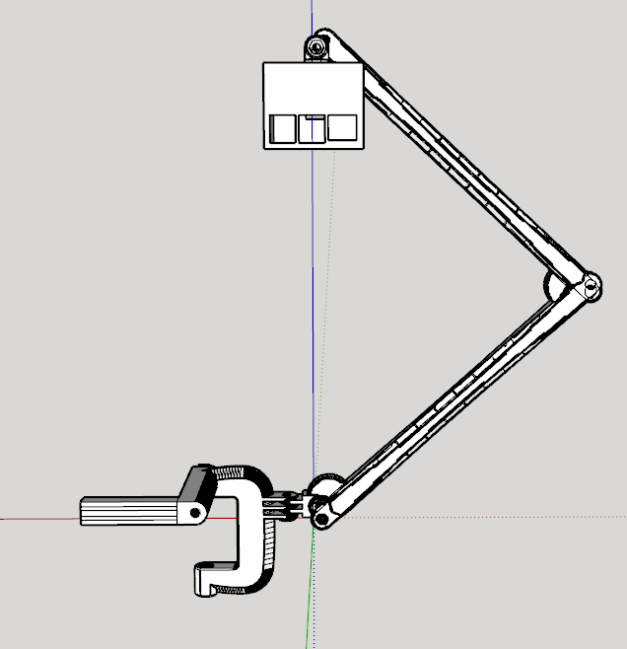

Figure Simulation: total assemble

By assembling the case, the arms, the document locator and other parts from the smartphone holder, total hardware can be assembled as Figure 85.

1. Modifying the design file

To be printed with 3D printers, designs should be solid objects. However, because some of design were not solid objects, the designs made by SketchUp cannot be printed directly. Therefore, the designs should be modified to proper design with a software Meshmixer. The software checks if the design is a solid object and modify the design to become a solid object automatically. The modified results are as shown in Figure 86 to Figure 89.

* 1. Case

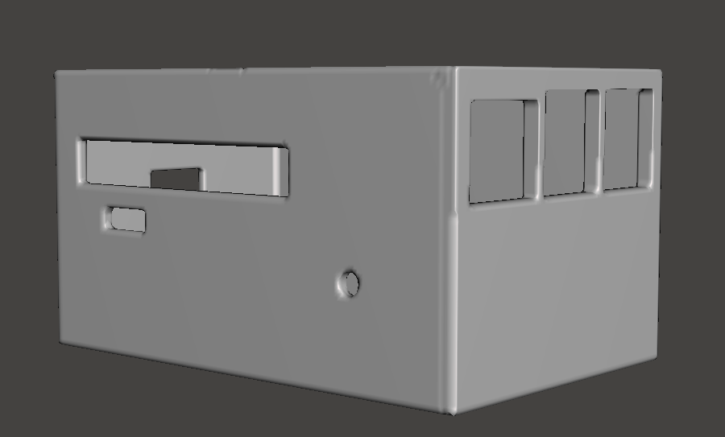

Figure modified case: front

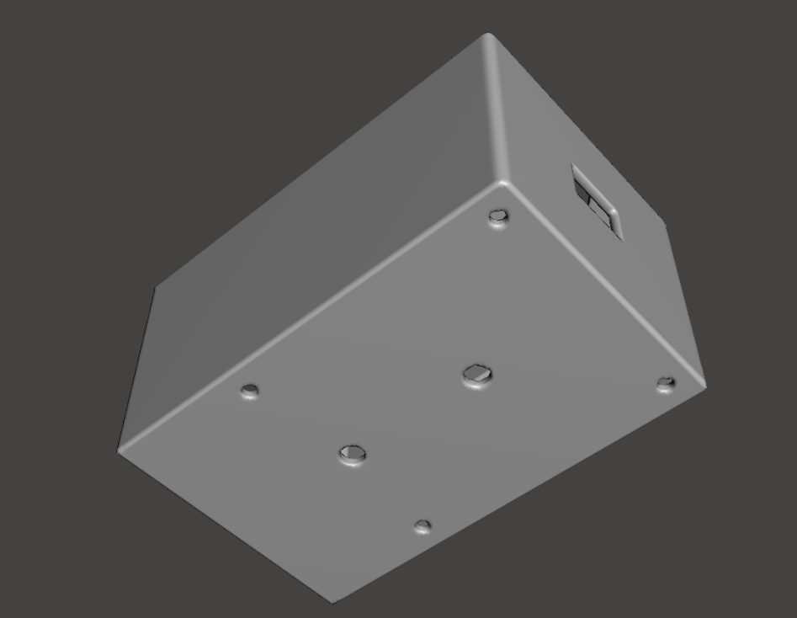

Figure modified case: bottom

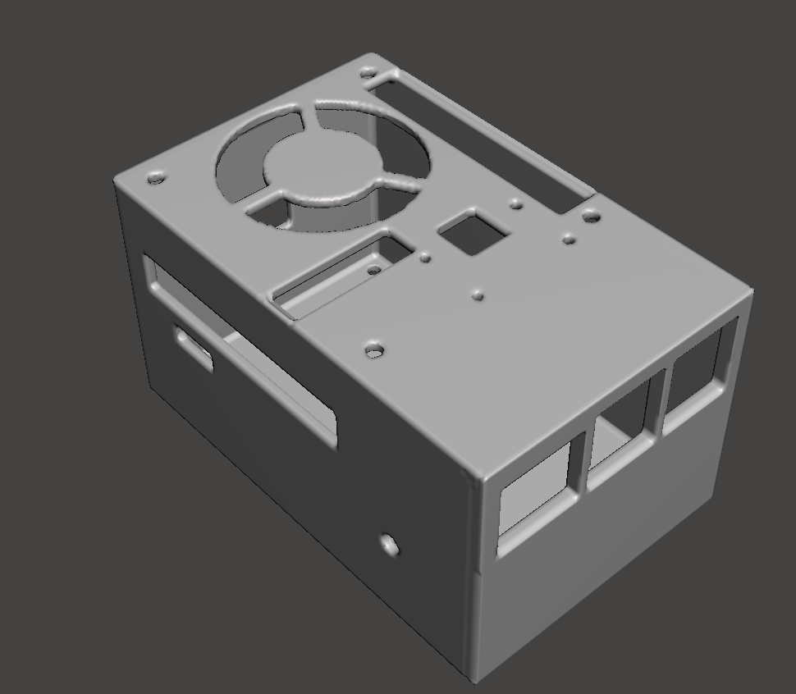

Figure modified case: top

* 1. Holder

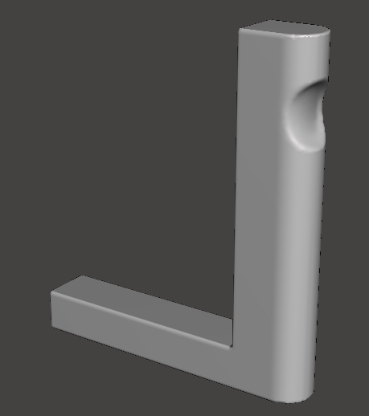

Figure modified holder: document locator

By modifying the document locator, make slot to add the locator to the holder easily. The locator can be used in both direction(right and left) to locate books and A4 documents.

1. Print the design

Two printers from different brands were used.

* 1. Makerbot Replicator+

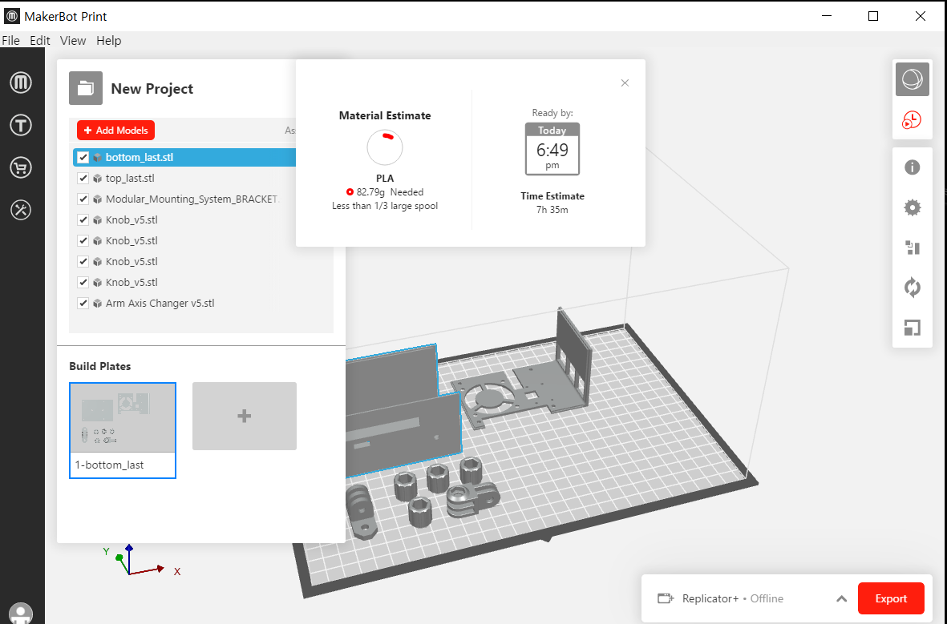

Figure 1st print with Makerbot

First print was done with Makerbot Replicator+. 82.79g of PLA filament was used and it took 7 hours and 35 minutes. Bottom and top parts of the case, nuts, axis changer and the part to attach the case to the holder were printed.

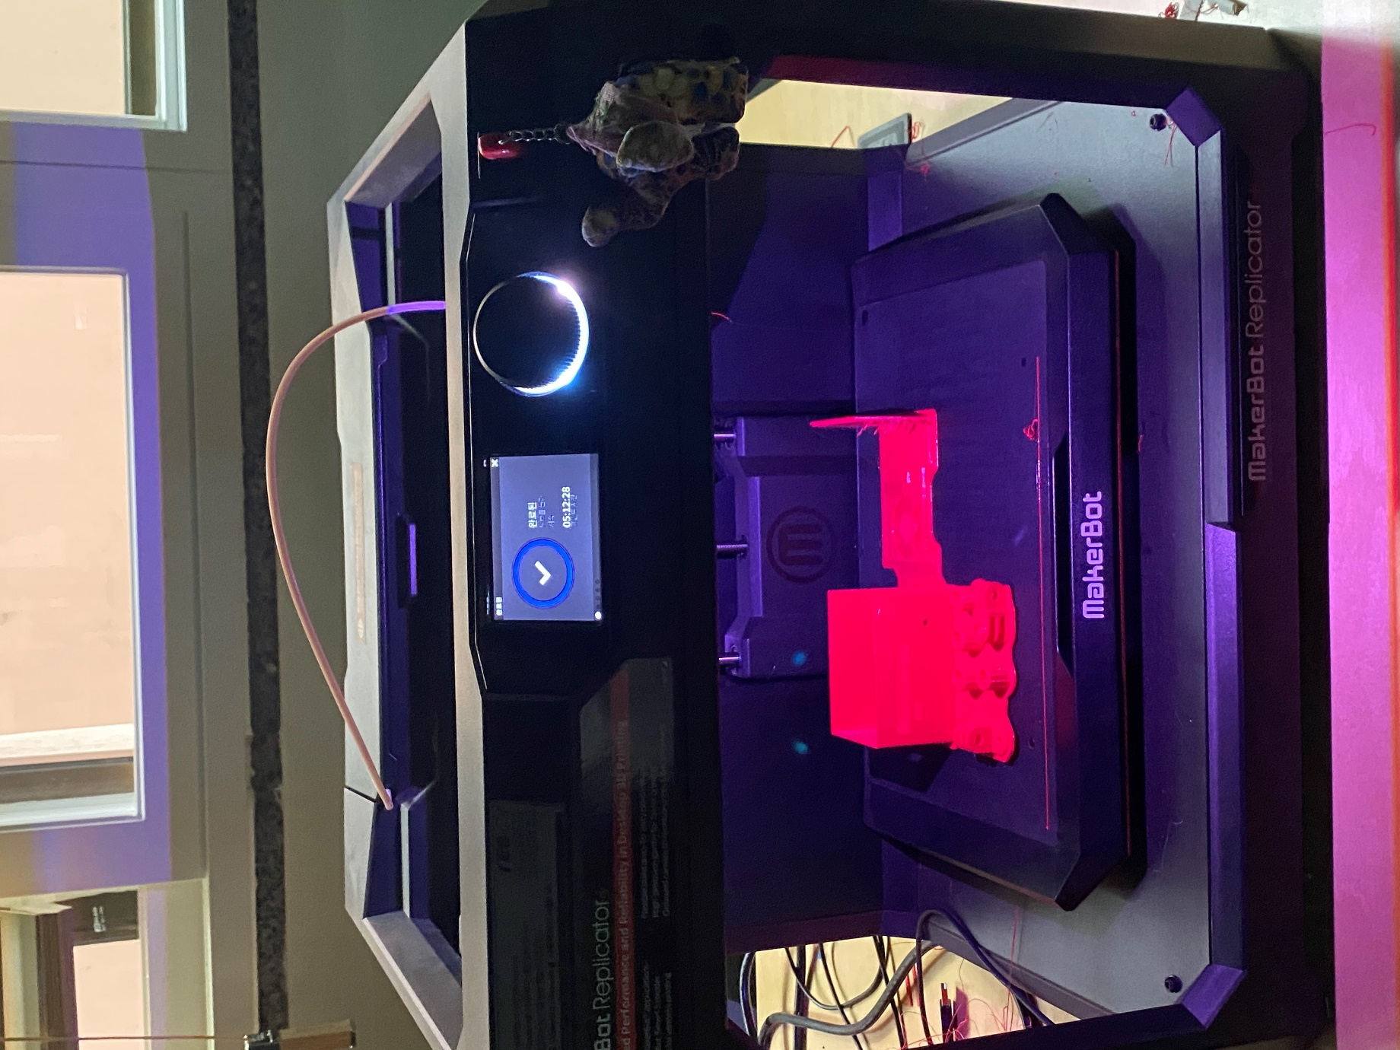

Figure printing the first part with Makerbot

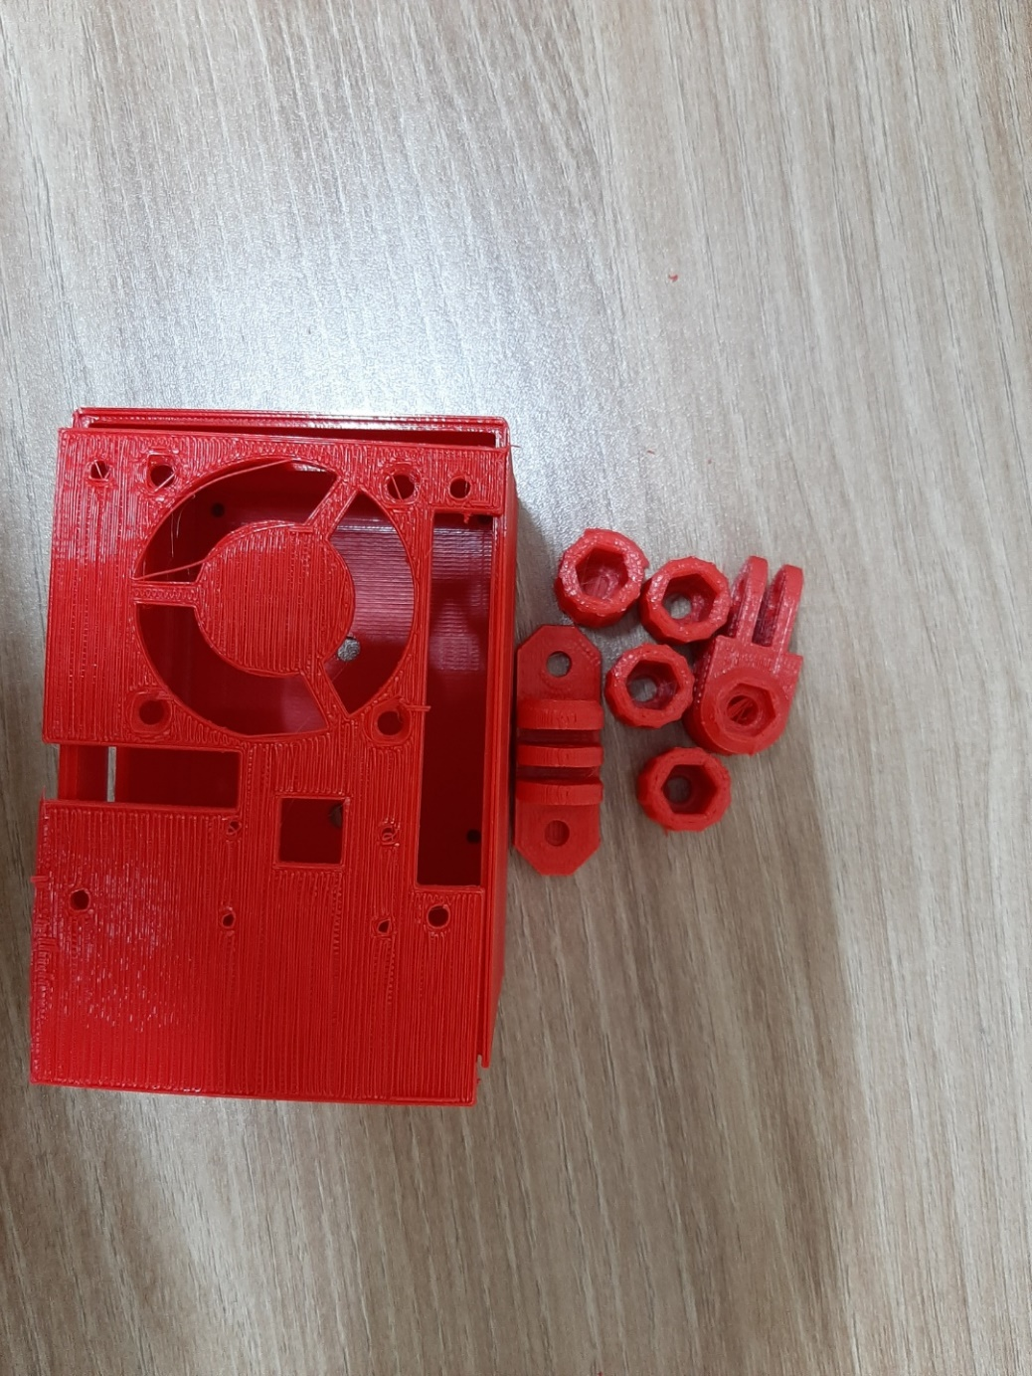

Figure printed design with Makerbot

However, some part of the case was not printed and the size of the case should be modified.

* 1. Cubicreator 310F

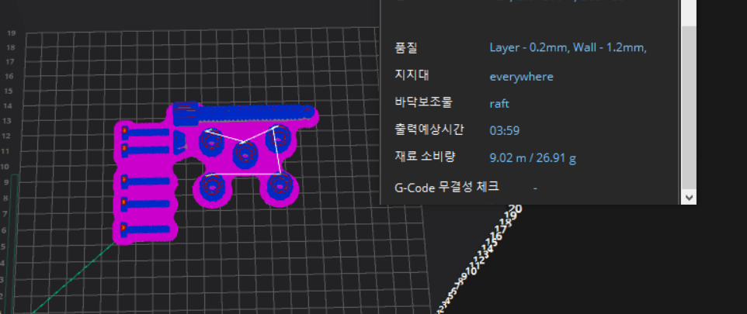

Figure 2nd printing with Cubicreator 310F

Second print contained bolts, nuts and a bolt for the clamp. With Cubicreator 310F, PLA+ type filament was used. PLA+ type filament has advantage of PLA type and ABS type. PLA type filament is good for big size design because there is less heat shrink. (Learning Factory, 날짜 정보 없음) However, ABS type filament is good for smaller design and it is easy to modifying after printing. Since the case and the holder had big size and also need delicate printing for small holes, choosing PLA+ type filament was reasonable.

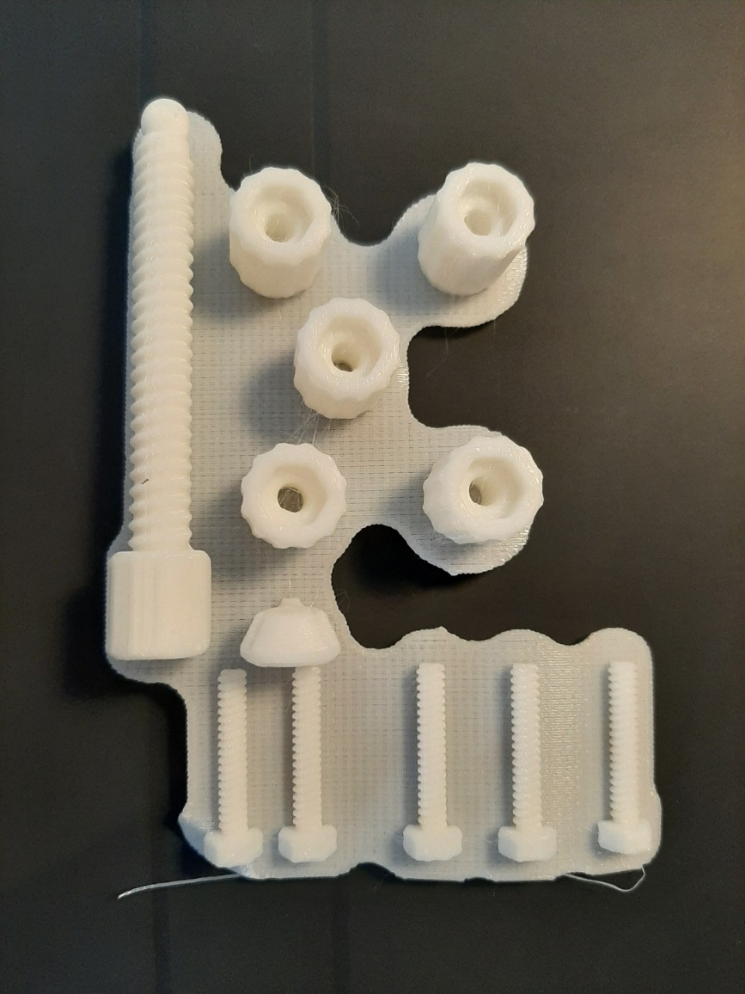

Figure printed 2nd part with Cubicreator 310F

The setting was the same with Makerbot Replicator+. However, the printed result was much more delicate. Therefore, after the second printing, printers from Cubicreator were used.

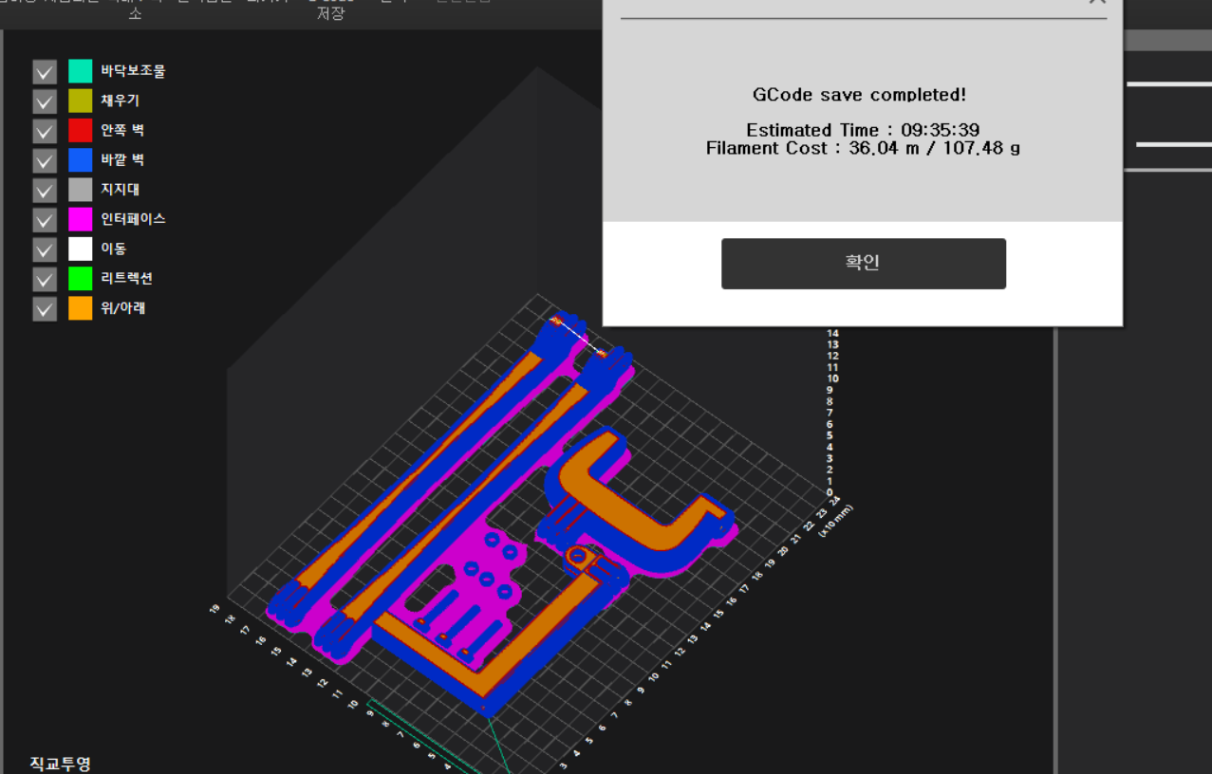

Figure 3rd printing with Cubicreator 310F

Third part was printed with Cubicreator 310F. It contained two arms for the case, bolts, the document locator, and the clamp. It took 9 hours 35 minutes to print and used 107.48g of PLA+ filament. Since the size of design that can be printed in the Cubicreator 310F was limited, the arm’s size was selected as 23cm which was the maximum length.

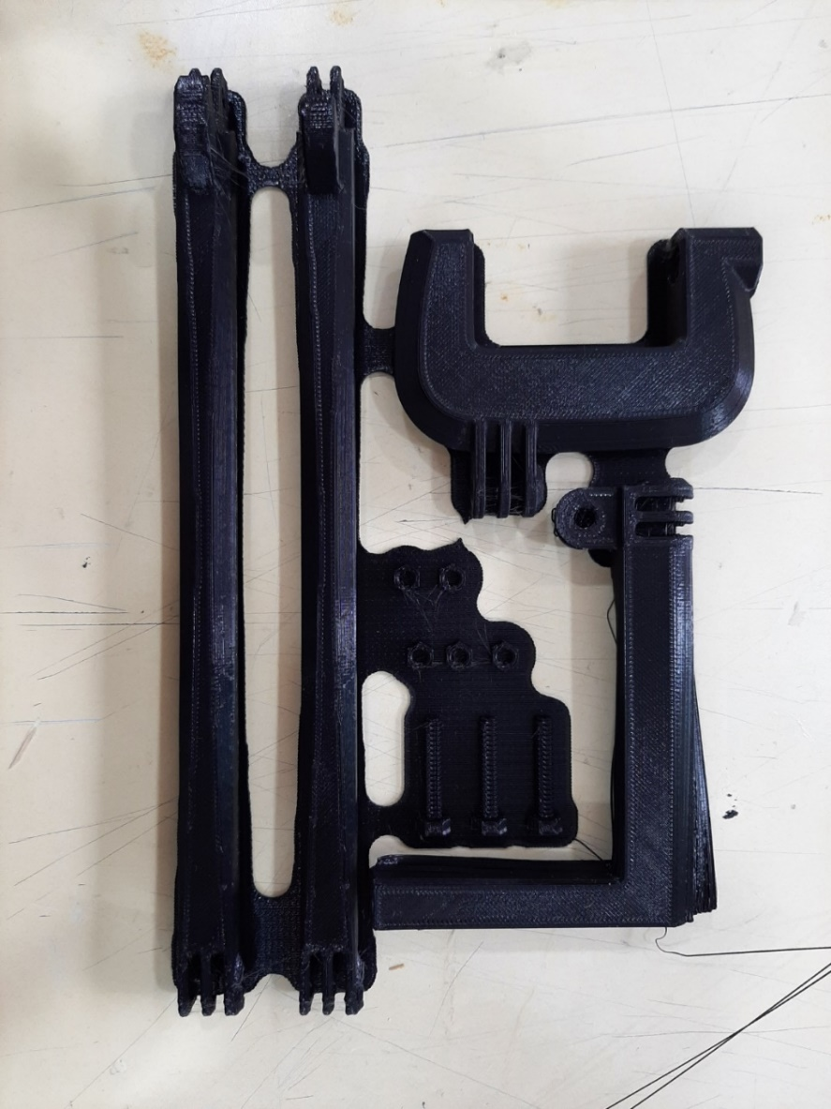

Figure 3rd part printed by Cubicreator 310F

The document locator was not printed properly. However, there was not enough time to print it again, the misprinted document locator was used in the simulation.

* 1. Cubicreator 210F

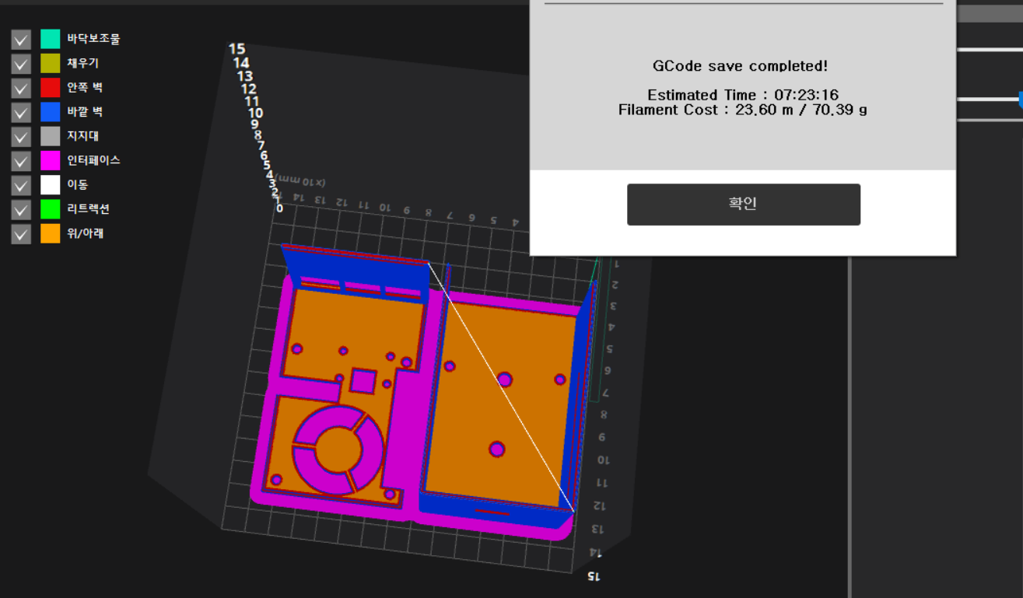

Figure 4th printing with Cubicreator 210F

Because the first printing for the case was not successful, bottom and top parts of the case was reprinted with Cubicreator 210F which has better quality than Makerbot Replicator+. The difference between Cubicreator 310F and Cubicreator 210F maximum size can be printed in the printers. Since the size of printing bed of Cubicreator 210F was enough to print the case, fourth printing was done by Cubicreator 210F. It needed 70.39g of PLA+ filament and took 7hours 23 minutes to print the fourth part.

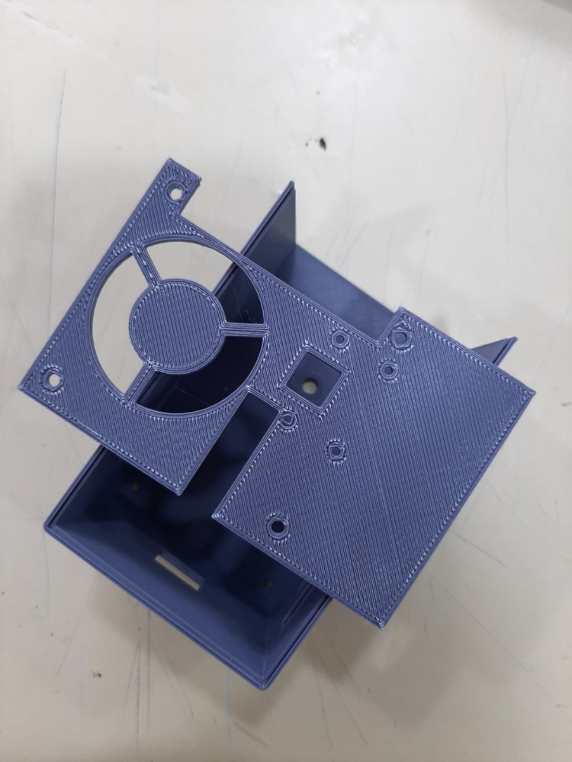

Figure 4th printed part by Cubicreator 210F

The parts which was not printed well with Makerbot Replicator+ were printed as expected with Cubicreator 210F.

1. Assemble

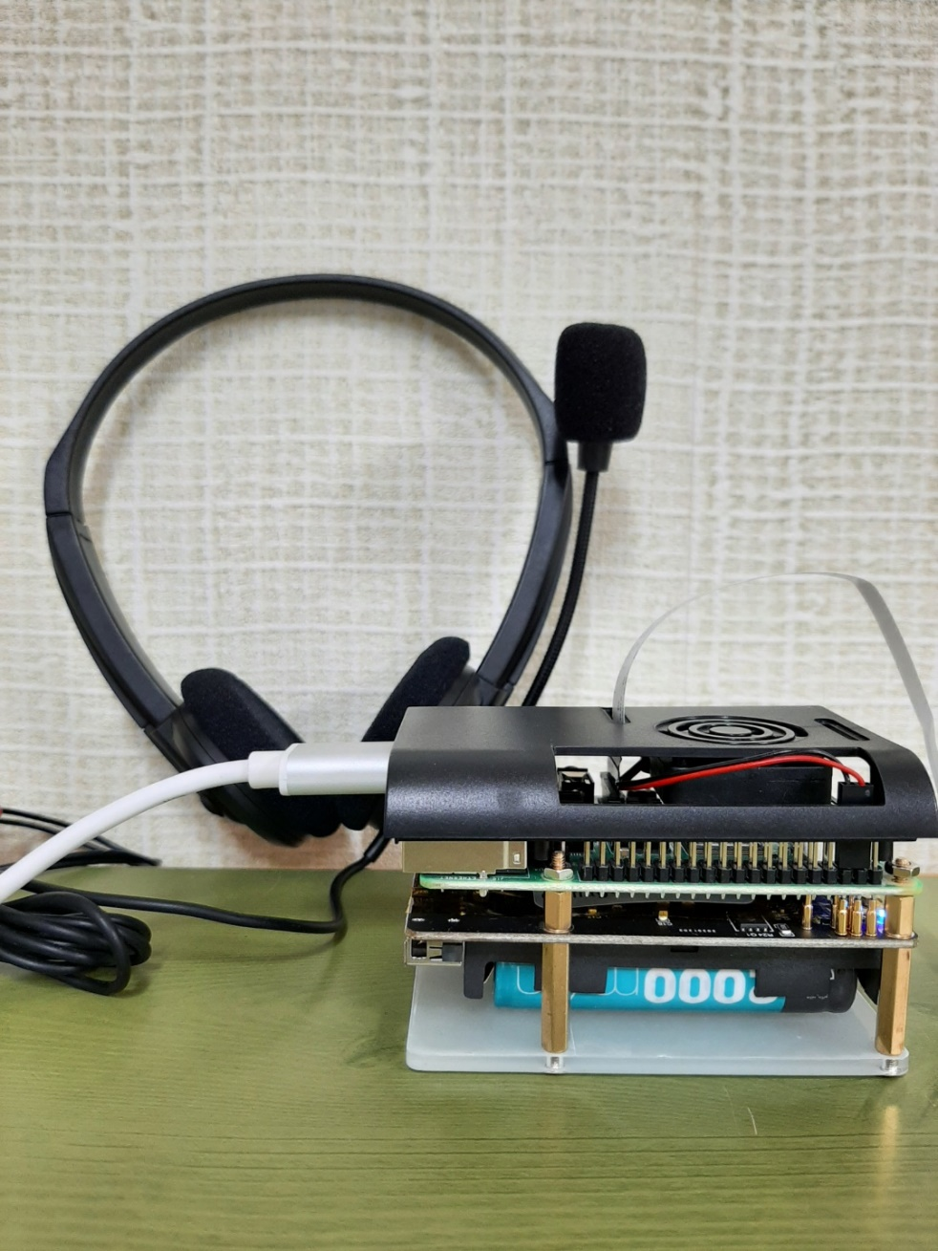

Figure the device

The device contains the Raspberry Pi and the battery module. Two modules are separated with PCB supports. 20mm and 5mm PCB supports were used in Figure 99. To fix the case and the device, the bottom part of the battery module was replaced with the bottom part of the case. Plus, four more 20mm PCB supports were used to fix the top part and the device as shown in Figure 100.

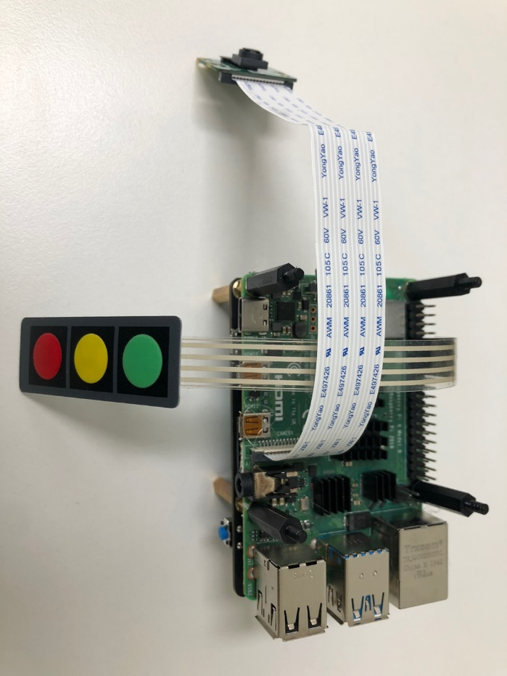

Figure additional PCB supports

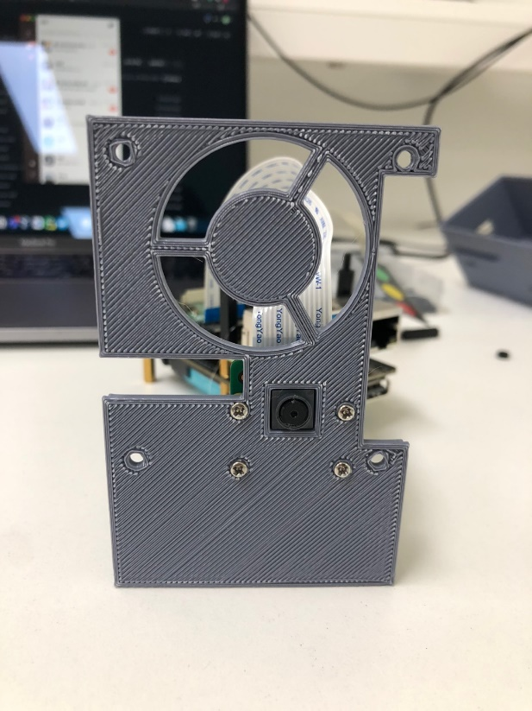 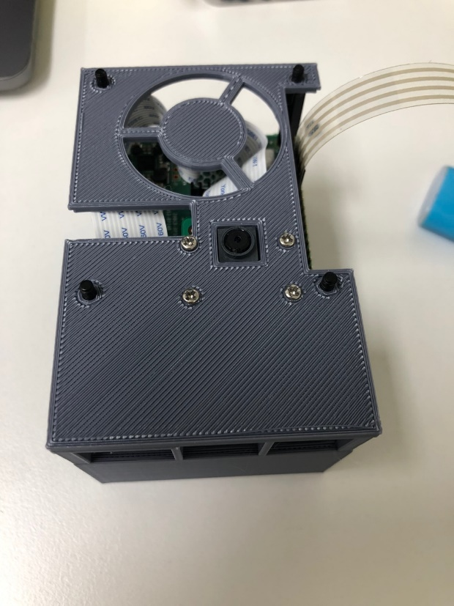

Figure fix the camera module and the top part of the case

The camera module was attached to the top part of the case with screw. The top part was fix to the device with PCB supports and nuts as shown in Figure 102.

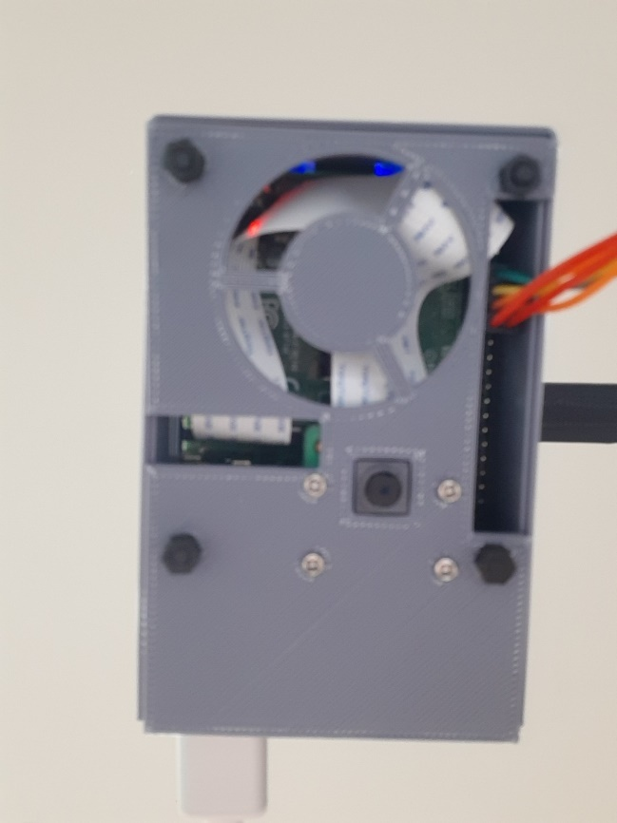

Figure fix the top part to the device

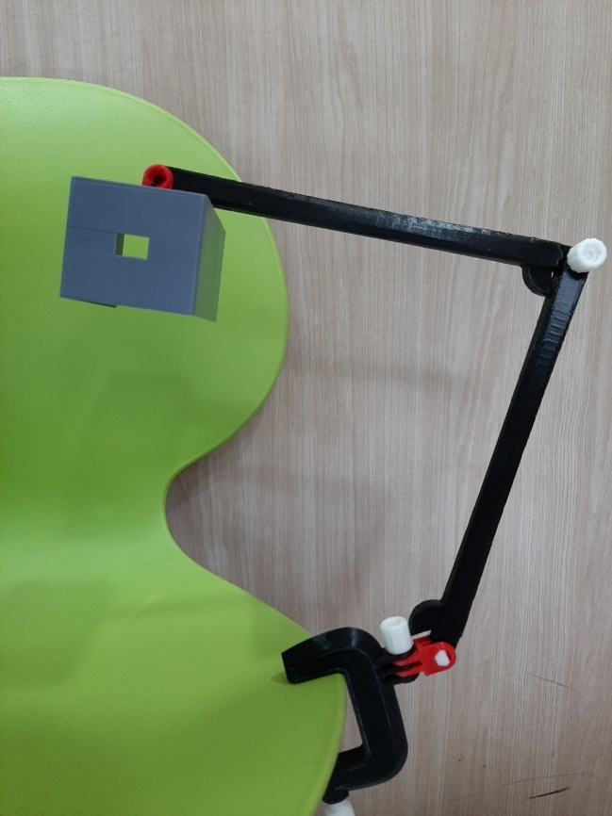

Figure Assemble the case and the holder

The case was assembled with the holder using the connector. Using the clamp, the holder was installed easily. Also the camera could take picture vertically.

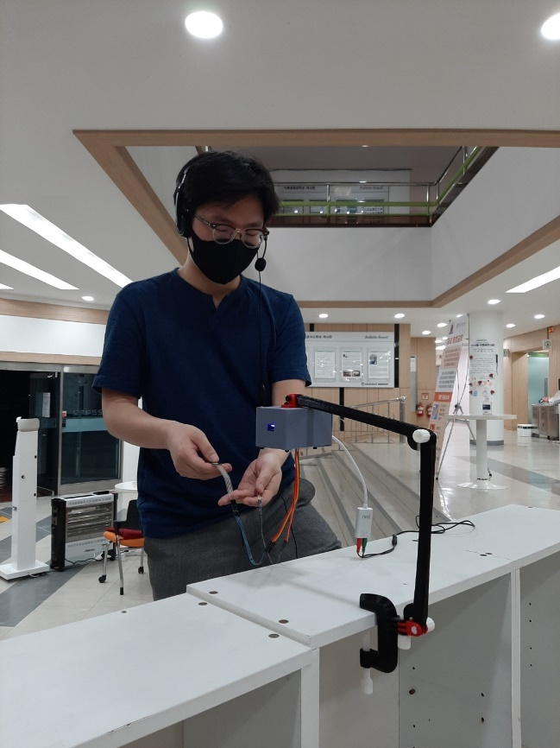

Figure Total hardware with user

User can use the device as shown in Figure 104. There are holes in the case to connect a headset and buttons. Users do not need to hold the device while reading documents. Plus, the holder can be easily carried anywhere user wants because it can be fold and carry within in a bag. The holder can be installed anywhere user wants with the clamp.

## Workflow

1. Take picture

When User commands “take picture.”

* 1. Saves voice command into wav file.
  2. Raspberry pi sends mp3 file with voice command to Google STT.
  3. Google STT sends converted text to Dialogflow.
  4. Dialogflow extracts intent and entity of the following text and returns fulfillment text.
  5. Raspberry pi interprets and follows fulfillment text. Raspberry pi takes picture of the document.
  6. Camera creates image file of the target document.
  7. Raspberry pi sends image file of the document to Google Vision API (OCR).
  8. Google Vision API returns text file of the target document.
  9. Raspberry pi sends text file to Google TTS.
  10. Google TTS returns mp3 file of the target document.
  11. Raspberry sends mp3 file to audio output.

1. Find dictionary

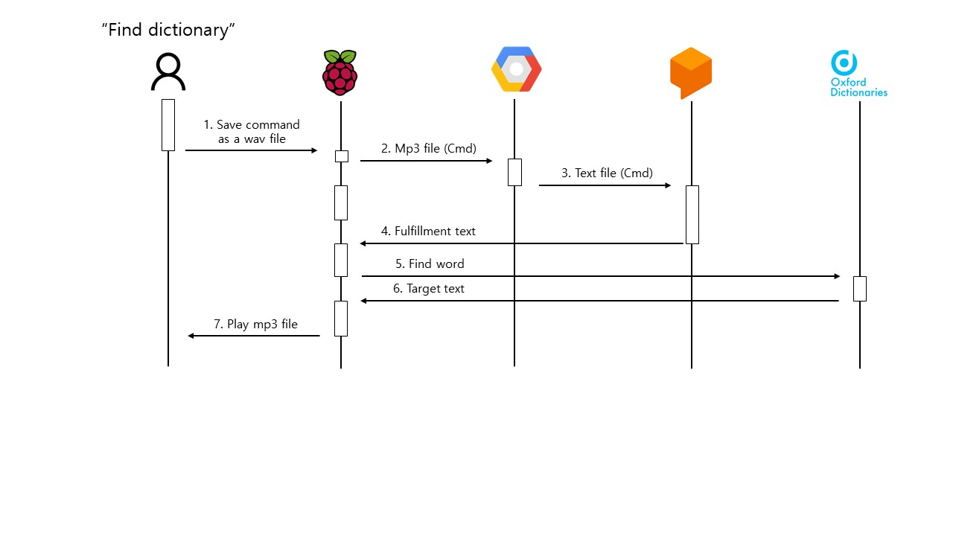

Figure Sequence diagram for voice control (find control)

When User commands “Find dictionary.”

1. Saves voice command into wav file.
2. Raspberry pi sends mp3 file with voice command to Google STT.
3. Google STT sends converted text to Dialogflow.
4. Dialogflow extracts intent and entity of the following text and returns fulfillment text.
5. Raspberry pi interprets and follows fulfillment text. Raspberry pi sends target word to Oxford Dictionary API.
6. Oxford Dictionary API sends the meaning of the word back to Raspberry pi
7. Raspberry sends mp3 file to audio output.
8. Control using Button Input

In case of button input that uses GPIO to detect button’s status change, it has limitation to implement unlike the voice command method (Soren, 2018). The limitation is that it is hard to execute complicated command needed many input information. In addition, it is not efficient to control every command using button input. As a result, it is designed to perform four tasks frequently used by using pressing buttons. The four tasks are “Increase the volume”, “decrease the volume”, “take picture” and “interrupt(pause / resume).

The follow sequence diagram is example for increasing volume.

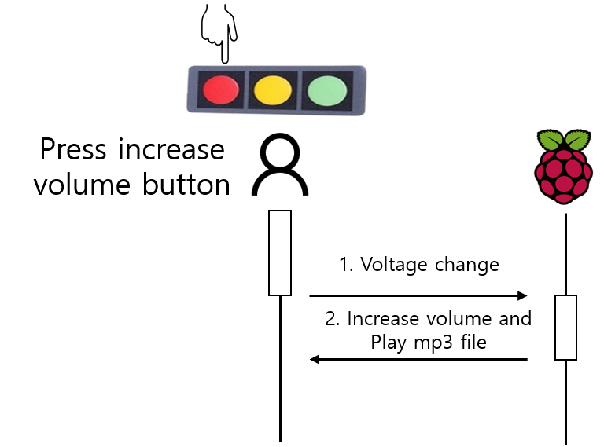

Figure Sequence diagram for button input(volume increase)

In the middle of playing the mp3 file through the speaker, when user presses buttons for increasing volume.

* 1. Raspberry pi detects voltage changes.
  2. According to pre-defined logic, increase the volume in audio setting and restart playing.

1. Voice command for using Firebase

There are three bookmark related commands, bookmark call, bookmark save and make category. These bookmark tasks’’ flows are the same and bookmark call flow is as follows.

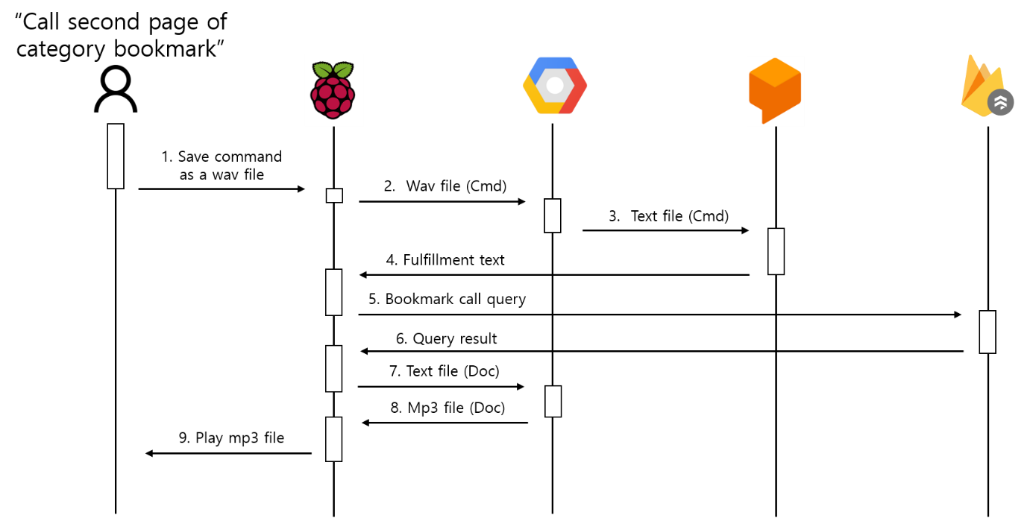

Figure Sequence diagram for voice control(bookmark call)

When User commands “Call second page of category bookmark

1. Saves voice command into mp3 file.
2. Raspberry pi sends wav file with voice command to Google STT.
3. Text enters into dialogflow’s input.
4. Dialogflow extracts intent and entity of the following text and returns fulfillment text.
5. Raspberry pi sends bookmark call query to firebase Cloud Firestore
6. After finishing query, returns query result.
7. Raspberry pi sends text file to Google TTS.
8. Google TTS returns mp3 file of the target document.
9. Raspberry sends mp3 file to audio output.
10. Voice command using weather api (VilageFcstInfoService, 날짜 정보 없음)

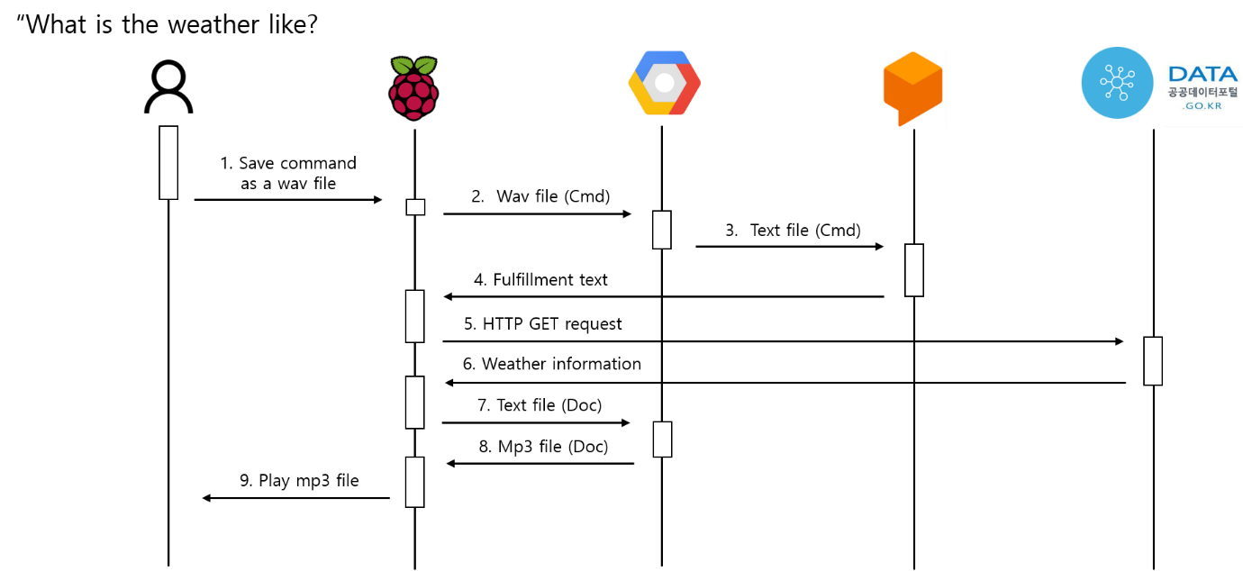

Figure Sequence diagram for voice control(weather control)

When User commands “What is the weather like?”

1. Saves voice command into mp3 file.
2. Raspberry pi sends wav file with voice command to Google STT.
3. Text enters into dialogflow’s input.
4. Dialogflow extracts intent and entity of the following text and returns fulfillment text.
5. Raspberry pi sends HTTP GET request to korea public data portal’s weather API.
6. Return weather information.
7. Raspberry pi sends text file to Google TTS.
8. Google TTS returns mp3 file of the target document.
9. Raspberry sends mp3 file to audio output.

# Result

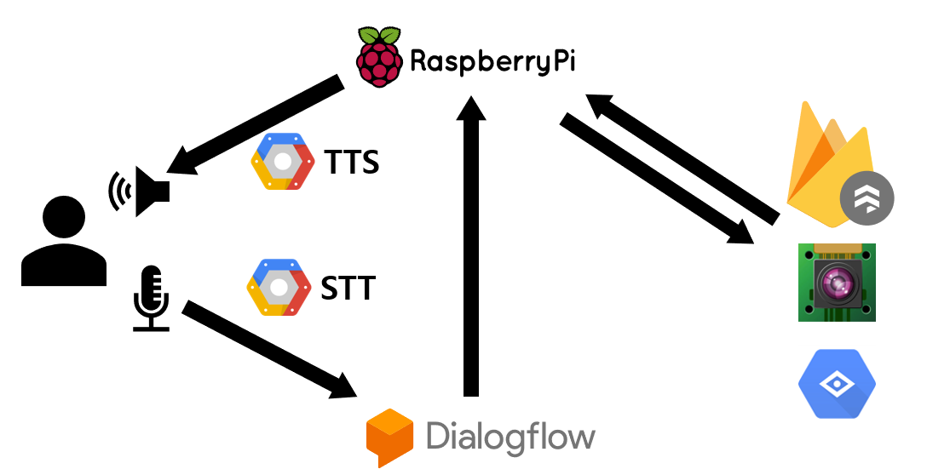

Figure overall architecture

The device has functions for reading, bookmarking. When the headset catches the hotword and send voice command to Google STT. The API changes the voice into text and send it to Dialogflow. According to the text, Dialogflow gives commands to Raspberry Pi. Raspberry Pi get and update data to Firebase or take picture with Pi cam. Google OCR API get text from the taken image and send the text to Raspberry pi. Raspberry Pi read the text with Google TTS API. Through these steps, users can hear the documents they want to read. Plus, for convenience users can get weather forecast and the time. The command can be given with the voice so that visually impaired can use the device without problems.

The results of voice recognition and reading documents in voice cannot be shown in the document. Several code running result are included in Implementation part and the overall running result of the device can be confirmed by the testing video of this project.

# Discussion

## Limitation

### Google API

Google api is not for free. If the PiReader is on sale, api fee will explode by many users. It can be resolved by subscription policy for user, but it is not a fundamental solution. We tried to make our model, but there are many problems like insufficient dataset, and undisclosed models that are proper for our project such as speech to text. Also, for 4 main deep learning technique, OCR, TTS, STT, find intent from sentence like dialog flow need powerful GPU server. This constraint make PiReader use Google api. PiReader may use non-deeplearning api such as tesseract or epseak but those show worse performance in test.

### Firebase

1. Document size limit of 1MB

Firestore places a limit of 1MB on the amount of data that can be stored in a single document. This is more than enough for most cases. However, things start to break down when pi reader make many bookmark contents in certain bookmark category(document). To solve this size limitation problem, the correct way to store bookmark contents is using one document per item in a whole new (sub)collection. However, it has the disadvantage of taking more time to perform db query. Hence, it is necessary to design db considering tradeoff between query performance and document size. (StevensonDoug, 2020)

1. Lower Performance of offline/cached queries

When app is executing a query while the app is online, Firestore executes that with all fast speed because it is able to use indexes to support that query. However, when app is executing a query offline with the Firebase SDK using locally cached data, there are no indexes available. A document “get” operation will be fast, but a query that could match multiple documents will not have the support of an index for performance. Without local indexes to accelerate queries against the local cache, the SDK has to scan cached documents to look for possible matches, and this could be very slow. In this reason, it is not easy to implement Pi reader in offline environment. (StevensonDoug, 2020)

### Device

PiReader use the cheap headset’s mic and sound card. Recorded audio files have many noises to simply use. This noise makes us to carefully set audio configuration, such as sampling rate and chunks. A more expensive mic and soundcard may crack those problem. Besides, PiReader use raspberrypi, and it make the heavy device. PiReader should consider use raspberrypi zero in Figure 110 that is simple version of raspberrypi. This project is provided original raspberrypi which make the weight performance worse.

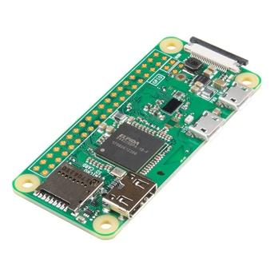

Figure Rapsberry Pi zero W (devicemart, 날짜 정보 없음)

### 3d modeling

The printers used in the project could not print delicate part properly. Therefore, holes to fix the camera did not fit well with the screws. Additionally, for some nuts, they did not fit well with bolts. Also, the document locator was not printed well. Since the size was limited to be printed in the printers, it was hard to print arms with enough length. Therefore, the angle between the camera and documents was not perfectly $180°$.

## Future Supplement

The response time of the command tends to be slow because the limit of using Google APIs. Plus, because the project uses API, the device cannot be used without the internet. Future goal to improve the quality of the device could be making offline version with high performance. (It could not be done in the project because the performance of offline version was low.) Designing more efficient database to save huge file or lots of bookmarks in the same category can be the future goal to implement better bookmark function.

# Conclusion

There are many limitations to what visually impaired people can read. They could not read something unless paper supports reading options such as e-book or is a braille book. E-book and braille book is only capable for the data they support meaning they are very insufficient. There are many tools on the market, but they do not offer a variety of functions. Besides, those tools need visual information to use. To provide a variety of functions, we made device controlled by voice and button using raspberry pi, and we named this as pi reader. Also various functions such as ARC(Audio Return Channel), TTS(Text-to-Speech), and STT(Speech to Text) are loaded in raspberry pi. With the various functions mentioned above, bookmark function and other additional functions(Time, Weather, Dictionary) were implemented as well. With the internet connected, the API(Application Programming Interface) provided by Google Cloud, and each API(Application Programming Interface) performs very well compared to the functions provided by open source because they extremely optimize the state of art deep learning model like wavenet. Quality of the function is very important for users who use the device. Because of the inability to utilize visual information, response time for the user should be optimized with the performance. By testing and applying, modules that can provide services as fast as possible with the real-time database system are chosen. It is confirmed by the project that each function of google cloud API, open-source tools work very well and can run within raspberry pi. Human uses optical sense 80%, auditory sense 10%, and rest 10%. Meaning most of the data human gets from is optical information and visually impaired people would have felt the world uncomfortable. Like the project, future device should consider input and output without optical sense for sure. (정선우, 2016)

Reference*[EV3-Python] Sound-eSpeak text to speech 사용하기*. (2019). Retrieved 4 24, 2021, from https://m.blog.naver.com/PostView.nhn?blogId=deoneo&logNo=221488512146&proxyReferer=https:%2F%2Fwww.google.com%2F

Adroit Market Research. (2019). *Global Assistive Technologies for Visually Impaired Market Size 2018, By Product [Educational devices (Braille computers, Braille writers, Reading machines), Mobility devices, Low vision devices, Others], By End users (Blind school, Hospital & Social orga.* Dallas: Adroit Market Research.

Baek, Y. (2019). Character Region Awareness for Text Detection. github.

Baoguang Shi, X. B. (2015). *An End-to-End Trainable Neural Network for Image-based Sequence Recognition and Its Application to Scene Text Recognition.* Cornel University.

devicemart. (n.d.). *[OEM] 라즈베리파이4 18650 5V 4A UPS 충전모듈 [SZH-RPI01*. (devicemart) Retrieved 6 10, 2021, from https://www.devicemart.co.kr/goods/view?no=12497514&gclid=EAIaIQobChMI_5PumvKY8AIVT3ZgCh3dlwT6EAYYASABEgJiovD_BwE

devicemart. (n.d.). *[SunFounder] 라즈베리파이 리튬배터리 전원 확장보드 [CZ0121]*. (devicemart) Retrieved 6 10, 2021, from https://www.devicemart.co.kr/goods/view?no=1383800

devicemart. (2019, 4 18). *[기초] 풀업? 풀다운? 저항*. (devicemart) Retrieved 60 10, 2021, from https://m.blog.naver.com/no1_devicemart/221516834246

devicemart. (n.d.). *Raspberr Pi Zero W*. Retrieved 4 24, 2021, from https://www.devicemart.co.kr/goods/view?no=1384051&gclid=CjwKCAjwtpGGBhBJEiwAyRZX2l63_F_ZxlHbdbvAEKQVunnVQN-RIiUOYh5qtqmEa-PfWxtRVxCVIhoCc-sQAvD_BwE

devidemart. (n.d.). *[RASPBERRY-PI] 라즈베리파이 카메라모듈 V2, 8MP (RPI 8MP CAMERA BOARD)*. (DeviceMart) Retrieved 6 10, 2021, from https://www.devicemart.co.kr/goods/view?no=1077951

FACT.MR. (2021, 3 18). *Technological Advancements to Augment Demand for Assistive Technologies for Visually Impaired With a CAGR of 8.6%*. (medgadget) Retrieved 6 10, 2021, from https://www.medgadget.com/2021/03/technological-advancements-to-augment-demand-for-assistive-technologies-for-visually-impaired-with-a-cagr-of-8-6.html

Firebase. (n.d.). *Cloud Firestore data model*. (Firebase) Retrieved 4 24, 2021, from https://firebase.google.com/docs/firestore/data-model#python

Firebase. (n.d.). *Cloud Firestore*. (Firebase) Retrieved 4 24, 2021, from https://firebase.google.com/docs/firestore

Firebase. (n.d.). *Supported data type*. (Firebase) Retrieved 4 24, 2021, from https://firebase.google.com/docs/firestore/manage-data/data-types

Geek, R. P. (2018, 12 24). *라즈베리파이 카메라 모듈 V2 스펙 리뷰와 사용기*. Retrieved 6 10, 2021, from https://geeksvoyage.com/raspberry%20pi/review-camera-v2-for-pi/

Google Cloud. (2021). *Dialogflow ES basics*. (Google Cloud) Retrieved 4 24, 2021, from https://cloud.google.com/dialogflow/es/docs/basics

GoogleCloudPlatform. (2021). *cloud-code-samples*. (Github repository) Retrieved 4 24, 2021, from https://github.com/GoogleCloudPlatform/cloud-code-samples

JadiedAI. (n.d.). EasyOCR. github.

Jungho, C. (2003). Implementation of TTS Engine for Natural Voice. *Journal of Digital Contents Society, 4*(2).

Kurmar, M. (n.d.). *Ancient text recognition: a review.* Retrieved 4 24, 2021, from https://www.researchgate.net/figure/Block-diagram-of-a-typical-OCR-system_fig1_340463467

Learning Factory. (n.d.). *About 3D PRINTER*. (SKKU) Retrieved 5 20, 2021, from https://sites.google.com/site/skkulf/Manual/3DP?authuser=0

MCU보드. (n.d.). *라즈베리파이4 18650 5V 4A UPS 충전모듈 SZH-RPI01*. (MCU보드) Retrieved 6 10, 2021, from http://www.11st.co.kr/products/2777926045?utm_medium=%EA%B2%80%EC%83%89&gclid=Cj0KCQjw0oCDBhCPARIsAII3C_HjdNjY7404fMXgKwU12d4RrljipeflscIRPJdwQQ1d6ylK7HDqn2EaAlrKEALw_wcB&utm_source=%EA%B5%AC%EA%B8%80_PC_S_%EC%87%BC%ED%95%91&utm_campaign=%EA%B5%AC%EA%B8%8

nanonet. (n.d.). A comprehensive guide to OCR with Tesseract, OpenCV and Python.

nanonet. (n.d.).

Onaolapo, J. O. (2014). *A Simplified Overview of Text-To-Speech Synthesis.*

picovoice. (n.d.). *porcupine*. (github) Retrieved 4 24, 2021, from https://github.com/Picovoice/porcupine

Prasad, P. D. (2015). VOICE RECOGNITION SYSTEML SPEECH-TO-TEXT. *Journal of Applied and Fundamental Sciences*, 191-195.

pygame. (n.d.). *pygame.mixer*. (pygame) Retrieved 6 10, 2021, from https://www.pygame.org/docs/ref/mixer.html

Raspberry Pi Foundation. (2016, 4). *Camera Module V2*. (Raspberry Pi Foundation) Retrieved 6 10, 2021, from https://www.raspberrypi.org/products/camera-module-v2/

*Relational vs. NoSQL data*. (2021, 1 19). (Microsoft) Retrieved 4 24, 2021, from https://docs.microsoft.com/ko-kr/dotnet/architecture/cloud-native/relational-vs-nosql-data

Soren. (2018, 2 8). *Using a push button with Raspberry Pi GPIO*. Retrieved 4 24, 2021, from nttps://raspberrypihq.com/use-a-push-button-with-raspberry-pi-gpio/

Stevenson, D. (2020, 1 2). *The top 10 things to know about Firestore when choosing a database for your app*. Retrieved 4 21, 2021, from https://medium.com/firebase-developers/the-top-10-things-to-know-about-firestore-when-choosing-a-database-for-your-app-a3b71b80d979

tesseract. (n.d.). *tessdoc*. (tesserect) Retrieved 4 24, 2021, from https://tesseract-ocr.github.io/tessdoc/ImproveQuality.html

VilageFcstInfoService. (n.d.). *Open API*. Retrieved 4 24, 2021, from https://www.data.go.kr/en/data/15057682/openapi.do

Xinyu Zhou, C. Y. (2017). *EAST: An Efficient and Accureate Scene Text Detector.* Cornel University.

YUN-HWAN, C. (2019). Korea will have the oldest population in 2045. *Korea JoongAng Daily*, 1.

정선우. (2016). 어둠속의대화. *정신의학신문*.

# Appendix

Our team meets twice a week by using google meet to talk about sharing what is done and what to do. When code-reviewing we use VSCode live share which provide remote write/read operation using VSCode. When making powerpoint and document like technical report we are using google docs which provide sharing document. we choose a role by related experience and personal interest. Also, we used gitkraken to version control. The following is role of the team.

- 2015311170 Joonkee Kim - team leader, OCR, main framework, device

- 2014314507 Kimsung Hyun - Database, Dialogflow

- 2014311409 Wonchul Shin - STT, TTS, Dialogflow

- 2014313678 Seojung Hwan - Device

- 2018312292 Dongwon Kim - Device, 3d pritner

Thanks to our passionate team members, our kind advisor professor Tamer and helping to purchase things staff Bora Song.